**Advanced Higher Computing Project – leBaie**

**2023/2024**

**Analysis**…………………………………………………………………………………….1

**Description of Problem**…………………………………………………………………………………………..1

**UML Use Case Diagram**……………………………………………………………………………….2

**Requirements Specification**…………………………………………………………………………2

**Project Plan**………………………………………………………………………………………………….7

**Design**……………………………………………………………………………………….X

**Advanced Higher Concepts**………………………………………………………………………………………X

**Integration**……………………………………………………………………………………………………………….X

**User-Interfaces**…………………………………………………………………………………………………………X

**Implementation**………………………………………………………………………. X

**Advanced Higher Concepts**………………………………………………………………………………………X

**Integration**…………………………………………………………………............…………………………………X

**User-Interfaces**……………………………………………………............……………………………………….X

**New skills/knowledge**………………………………………………………............……………………......X

**Log of Ongoing Testing**………………………………………………………...........…………………………X

**Testing**……………………………………………………………………………………… X

**Test Plan**…………………………………………………………………………………………………………………..X

**Requirements Testing**………………………………………………………………………………………………X

**Test Case Results**………………………………………………………………………………………………………X

**Evaluation**………………………………………………………………………………… X

**Fitness for Purpose**…………………………………………………………………………………………………..X

**Maintainability** ……………………………………………………………………………………………………....X

**Robustness** .........………………………………………………………………………………………………………X

AH Project Analysis

I will develop an online storefront called "leBaie".  The website will allow registered users to list their own items/products to the site and be able to view and edit their details (profile). Furthermore "leBaie" should allow all users to browse the website and view products listed by others (Each item listed will have a picture price and name associated with it, which is then stored in the database). Registered Users and Guests should also be able to add available products to their basket. Consumers should be able to easily access their basket (stored in a MySQL database), search for products either by search or browsing in the appropriate categories and see the chosen products of the month. When users first enter the website, they will be on the landing page which presents them with options to sign in, register or seamlessly browse the website as a guest and add or remove items from their basket as they see fit. Registered Users will be able to list their own products on the site as well, products listed must have an image, product name and the category associated with the item being listed (this will be done by storing the file pathway in the SQL database).

Due to my project meeting the Advanced Higher Computing Criteria, it is a suitable project which consists of easily managed inputs from users- making it simple to validate inputs entered by users. My project will authenticate all login details entered by users by comparing the entered details to the ones stored in the database, update users’ profiles inside database if they choose to change their details, insert items added to basket into the database, I will also utilise session variables across the site and allow users to delete items from their basket (which then deletes it from the database) this will be done via integrating the SQL databases using PHP.

Constraints

 The technical, economic, legal, and time constraints that apply to this project include:

* MySQL database that is used to store products listed on website, customer queries, user’s baskets and user login details.
* To access the database using MySQL, I will use Windows 11 Operating System along with Mac OS.
* To run the database integrated with the webserver I will use xampp control panel.
* There will be no costs involved in the development of the project as I am using software that is fully licensed and available in school for free.
* Notepad ++ 8.5.7 will be used to develop the site as this is the program, I feel the most confident developing with
* The project must be completed by the deadline of the end of February.

Project Plan

|  |  |  |  |  |
| --- | --- | --- | --- | --- |
| Stage | Task | Duration (Days) | Possible Start Date | End Date |
| ANALYSIS  **6 DAYS** | Description of Project | 3 | 26/09/23 | 29/09/23 |
| UML Diagram | 1 | 01/10/23 | 02/10/23 |
| Requirement Spec | 1 | 02/10/23 | 03/10/23 |
| Project Plan | 1 | 04/10/23 | 05/10/23 |
| DESIGN  **12 DAYS** | AH Concepts | 1 | 06/10/23 | 07/10/23 |
| Design Data Structure | 3 | 09/10/23 | 12/10/23 |
| Integrate Project | 2 | 13/10/23 | 15/10/23 |
| Ensure program is fit for purpose | 1 | 14/10/23 | 15/10/23 |
| User Interface | 5 | 16/10/23 | 21/10/23 |
| IMPLEMENTATION  **35 DAYS** | Ensure Program Matches Design | 8 | 22/10/23 | 30/10/23 |
| Integration | 10 | 01/11/23 | 11/11/23 |
| User Interface | 9 | 12/11/23 | 21/11/23 |
| New Skills | 5 | 21/11/23 | 26/11/23 |
| Ongoing Testing | 3 | 26/11/23 | 29/11/23 |
| TESTING  **9 DAYS** | Test Plan | 4 | 01/12/23 | 05/12/23 |
| Requirements Testing | 3 | 07/12/23 | 10/12/23 |
| Test Cases | 2 | 11/12/23 | 13/12/23 |
| EVALUATION  **5 DAYS** | Fitness For Purpose | 2 | 10/01/24 | 12/01/24 |
| Maintainability | 2 | 14/01/24 | 16/01/24 |
| Robustness | 1 | 17/01/24 | 18/01/24 |

**UML diagram**

**End User requirements**

The end user should be able to create an account or sign in

The end user should be able to view and search for a variety of products on the website

The end user should be able to add items to their basket

The end user should be able to view products by clicking on a product category page

The end user should be able to list products on the site if they have logged in or registered

The end user should be able to view the products of the month

The end user should be able to view their baskets and remove items from them

Then end user should be able to view and edit their profile details

The end user should be able to submit queries issues their having

**Functional Requirements**

the website should have a database table that stores customer queries that are entered

the website should have the appropriate products for the category selected and display them

the website should have a login and registration page that also validate users’ details

The website should display and return products if it corresponds to users search

The website should allow users to add items to their basket using SQL DB

The website should have a listing page that allows registered users to enter details about their listing and upload it

The website should display the products of the month

The website should display buttons that allow users to add and remove items from their basket

The website should contain form elements that allow users to update their profile details

Requirement Spec

For my project to be able to fulfil its requirements, it must meet several criteria:

My project will comply with GDPR as it does publicly share user’s information and it’s securely stored in a SQL database. The form submissions containing sensitive data is shared using the POST method as it does not display users’ info in URL unlike the GET method.

Registering an Account Requirements

Users of my system will be able to create an account if they enter a unique username, first name, surname, their date of birth and a password for their account. The registration functionality will include:

1. The registration page will allow the user to enter

a) A unique username

b) a valid forename and surname

c) a valid date of birth

c) A password that must be re-entered

2. The user will then press the “registration” button, which will check that the username, forename, surname and password they have entered is valid by:

a) Checking that no field is empty

b) Checking that the password is within 20 characters and the username is within 10, date of birth is before 31st December 2013 and that forename and surname are less than 20 characters.

c) ensure password and confirm password fields match via JavaScript function

d) Importing stored usernames from the SQL database table “registration”

e) Checking that the username does not already exist in the database table

3. If the user passes this validation:

a) The User will be redirected to the home landing page for logged in users and their details are inserted into the database table “registration”

Login System Requirements

Login System Requirements Users of my system will be able to create a unique username-password combination to access the full functionalities of the site. The login functionality will include:

1. The Login page will allow the user to enter

a) A valid username

b) A valid password

2. The user will then press the “Login” button, which will check that the username and password they have entered is valid by:

a) Checking that neither field is blank

b) Checking that the password is within 20 characters and the username is within 10

c) Importing stored usernames and passwords from the SQL database table “registration”

d) Checking that the username and password combination exists in the table

3. If the user passes this validation:

a) The User will be redirected to the home landing page for logged in users with a popup stating they have successfully signed in/registered. Session variable will also be set.

Listing a product requirement

Signed in Users of my system will be able to list a product on the website when a Product Name, Product Category, Price and Image are entered into the form. The listing functionality will include:

1. The listing page will allow the user to enter

a) A valid product names

b) a product category from a drop-down list

c) a valid price

c) An image is attached

2. The user will then press the “create listing” button, which will check that the product name, product category, price and image they have entered/selected is valid by:

a) Checking that no field is empty

b) Checking that the product name is within 20 characters, a category is selected, price within 0 and 100,000 is entered.

3. If the user passes this validation:

a) The User will be redirected to the home landing page for logged in users that displays a popup confirming listing was successful and their listing is inserted into the database table “products”. Session variable will also be set.

Editing profile requirements

Signed in Users of my system will be able edit their profile on the website when the edit button on the profile page is pressed. forename, surname, date of birth and password are the values of the form elements which can then be edited by the user. The listing functionality will include:

1. The registration page will allow the user to enter

a) a valid new forename and surname

b) a valid new Date of Birth

c) a valid new date of birth

c) A valid new password

2. The user will then press the “save changes” button, which will check that the forename, surname and password they have entered is valid by:

a) Checking that no field is empty

b) Checking that the password is within 20, date of birth is before 31st December 2013 and that forename and surname are less than 20 characters.

3. If the user passes this validation:

a) The User will be redirected to profile page and their details are updated in the database table “registration” and the updated details will be displayed

Contact Us requirements

Users of my system will be able submit queries/issues on the website form on the contact us page when the submit button on the contact us page is pressed. username, email, subject and descriptions are the form elements which can then be edited by the user. The contact us functionality will include:

1. The contact us page will allow the user to enter

a) a valid username (not required)

b) an email (required)

c) subject (required)

c) a description (required)

2. The user will then press the “save changes” button, which will check that the email, subject and description they have entered is valid by:

a) Checking that no fields mentioned above is empty

b) Checking that the username is within 10 characters (if entered), email within 30 characters and that subject is within 250 characters (validated in SQL table).

3. If the user passes this validation:

a) The User will be redirected to the logged in-home page with a popup stating that the query is submitted if the username entered in the form matches one in the registration table, if the username field was left empty it will redirect the user to the homepage for guests which will display a popup stating that query was successfully submitted. The form data will also be inserted into the database table “contactUs” so that the query can be viewed at a later date so user can get assistance.

Basket requirements (registered users and guests)

Users of my system will be able to view items they added to their basket in previous pages, which is then displayed in the basket page. The contact us functionality will include:

1. The basket page will allow users to

a) remove items from basket

2) display user’s basket

3) checkout

1a. if the user presses the “remove from basket” button, it will proceed to remove that item from the user’s basket in either the “basket” table or “guestBasket” table:

a) Select item from “basket” or “guestBasket” tables that corresponds to the product. Then the database will be queried, and then the item will be removed from the database table. The user will then be redirected back to the basket page and it will display the rest of the basket or state that its empty

2. The user’s basket will be displayed using php and retrieving products added to basket from the SQL table “guestBasket” for unregistered users and “basket” for signed in users:

a) SELECT items in “basket” table that correspond with have the same username as the session variable started after the user signed in/registered (FOR SIGNED IN USERS ONLY)

b) QUERY database (SIGNED IN USER ONLY)

C) Display results in table that were queried (SIGNED IN USER ONLY)

d) SELECT all products in the table “guestBasket” (GUEST ONLY)

e) QUERY database (GUEST ONLY)

f) Display results in table queried from database table (GUEST ONLY)

3. CHECKOUT

Due to budget limitations and time constraints I was unable to implement this feature.

Clothing, Electronics, Vehicles and Game page requirements (registered users and guests)

Users of my system will be able to browse different categories for products that have been listed (Can access hyperlinks which will take them to pages displaying these via using the navigation bar). The pages listed above functionality will include:

1. The pages for clothing, electronics, vehicles and game will allow users to:
2. Access navigation bar – contains links to home, clothing, electronics, vehicles and game pages

2. display products from appropriate categories

3. allow users to add items to basket

1a) Clothing, Electronics, Vehicles and Game pages will feature a navigation bar which will contain hyperlinks to the Home, Clothing, Electronics, Vehicles and Game pages clothing

2) The products for the appropriate category for the page will be displayed using php and retrieving products from the “products” table, which will then products that align with the page of the category being viewed.

b) QUERY database

c) Display results from “products” where appropriate conditions are met

3) the users will be able to add items that are displayed into their basket when “add to basket” button is clicked

a) assign value of the product name to the product name of the row being displayed

b) insert the value of the product name into the database table “guestBasket” for users who haven’t signed in and “basket” table for users that are logged in/registered

Home page requirements (Registered Users and Guests)

Users of my system will be able to browse products of the months that have been listed. They can access hyperlinks which will take them to different product category pages displaying these via using the navigation bar, login or register or proceed to add products to basket and browse website as guest. The home functionality will include:

1. The pages for the home pages will allow users to:
2. Access navigation bar – contains links to home, clothing, electronics, vehicles and game pages

2. display products of the month

3. allow users to add items to basket

1a) Home pages will feature a navigation bar which will contain hyperlinks to the Home, Clothing, Electronics, Vehicles and Game pages clothing

2) The products of the month will be displayed using php and retrieving products via a select statement which looks for names of the products that were chosen as the products of the month from the “products” table.

b) QUERY database

c) Display results from “products” where appropriate conditions are met

3) the users will be able to add items that are displayed into their basket when “add to basket” button is clicked

a) assign value of the product name to the product name of the row being displayed

b) insert the value of the product name into the database table “guestBasket” for users who haven’t signed in and “basket” table for users that are logged in/registered

DESIGN

USER INTERFACES

Login Page

Registration Page

About us page

Clothing Page

Electronics Page

Games Page

Listing Page

Failed Search

Vehicles Page

Basket Page (Guest)

Contact Us Page (Guest)

Home Page (Guest)

Results page (guest)

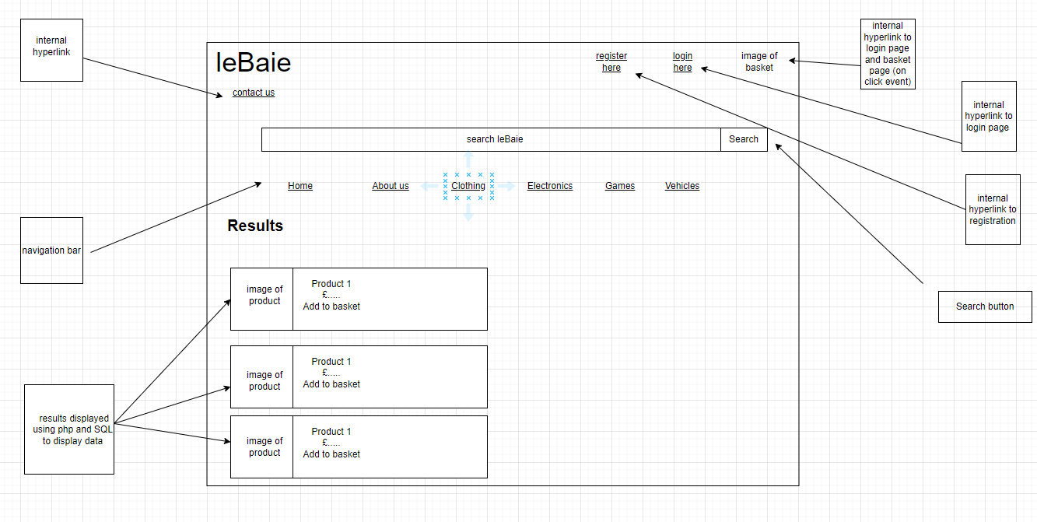

Basket page when empty (Guest)

Basket when empty (registered user)

Basket page (registered user)

Contact us page (registered user)

Profile page (registered user)

Edited profile form page (registered user)

Home page (for registered users that have logged in/signed up)

Results page (for registered users)

Pseudocode

Registration Page

1. RECEIVE HTML FORM VALUES USING POST AND ASSIGN TO PHP VARIABLES
2. SETUP SESSION VARIABLES FOR USERNAME, FIRSTNAME, SURNAME, DATE OF BIRTH AND USERS’ PASSWORD ASSIGNED VIA PHP VARIABLES
3. ASSIGN CONNECTION DETAILS TO PHP VARIABLES
4. CONNECT TO DATABASE
5. IF ERROR CONNECTING
6. DISPLAY ERROR MESSAGE
7. END IF
8. QUERY DB TO SELECT USERNAMES FROM REGISTRATION TABLE THAT MATCH PHP VARIABLE THAT WAS ASSIGNED TO USERNAME
9. IF NUMBER OF RESULTS>0
10. DISPLAY ERROR SAYING USERNAME ALREADY EXISTS AND REDIRECT USER TO FAILED REGISTRATION PAGE
11. ELSE
12. INSERT USERS’ DETAILS INTO REGISTRATION TABLE
13. IF QUERY CHECKING INSERT AND CONNECTION IS SUCCESSFUL
14. DISPLAY SUCCESS MESSAGE
15. END IF
16. REDIRECT TO REGISTERED HOME PAGE

Login Process

1. START SESSION
2. RECEIVE HTML FORM VALUES VIA POST AND ASSIGN TO PHP VARIABLES
3. SETUP SERVER DETAILS USING PHP VARIABLES
4. SET VALID TO FALSE
5. CONNECT TO SERVER
6. IF CONNECTION FAILED DISPLAY ERROR MESSAGE
7. END IF
8. SELECT USERNAME, FIRSTNAME, SURNAME, DOB AND PASSWORD FROM DATABASE TABLE REGISTRATION WHERE THE USERNAME IN TABLE MATCHES PHP VARIABLE ASSIGNED FROM FORM
9. QUERY DATABASE AND ASSIGN RESULTS TO PHP VARIABLE
10. IF NUMBER OF RESULTS>0
11. IF PASSWORD STORED IN DATABASE TABLE MATCHES THE PHP VARIABLE USING FORM VALUE
12. SET VALID TO TRUE
13. SETUP SESSION VARIABLES FROM THE DATABASE ROW RESULT
14. END IF
15. END IF
16. CLOSE CONNECTION TO DATABASE
17. IF VALID IS TRUE
18. REDIRECT USER TO REGISTERED HOME PAGE
19. ELSE
20. REDIRECT USER TO FAILED LOGIN PAGE
21. END IF

Listing Process

1. START SESSION
2. RECEIVE HTML FORM VALUES VIA GET AND ASSIGN TO PHP VARIABLES
3. SETUP SERVER DETAILS USING PHP VARIABLES
4. CONNECT TO SERVER
5. IF CONNECTION FAILED
6. DISPLAY ERROR MESSAGE
7. END IF
8. INSERT HTML FORM VALUES THAT WERE ASSIGNED TO PHP VARIABLES INTO PRODUCTS TABLE
9. IF QUERY IS SUCCESSFUL
10. DISPLAY MESSAGE STATING THAT PRODUCT IS LISTED
11. REDIRECT USER BACK TO REGISTERED HOME PAGE
12. ELSE
13. DISPLAY ERROR MESSAGE
14. END IF

CONTACT US PROCESS

1. START NEW SESSION
2. RECEIVE HTML FORM VALUES VIA GET
3. ASSIGN CONNECTION DETAILS TO PHP VARIABLES
4. IF CONNECTION FAILED
5. DISPLAY ERROR MESSAGE
6. END IF
7. QUERY DATABASE TO SELECT USERNAME FROM DATABASE THAT MATCHES THE PHP VARIABLE HOLDING HTML VALUE
8. ASSIGN RESULTS FOUND TO PHP VARIABLE
9. INSERT VALUES INSIDE PHP VARIABLES FROM HTML VALUES INTO CONTACTUS TABLE
10. IF QUERY WAS SUCCESSFUL
11. REDIRECT USER TO REGISTERED HOME PAGE THAT WILL DISPLAY SUCCESS MESSAGE
12. ELSE
13. REDIRECT USER TO GUEST USERS HOME PAGE THAT WILL DISPLAY SUCCESS MESSAGE
14. END IF

DISPLAYING PROFILE

1. START SESSION
2. ASSIGN SESSION VARIABLES TO PHP VARIABLES
3. ASSIGN CONNECTION DETAILS TO PHP VARIABLES
4. CONNECT TO SERVER
5. IF SESSION VARIABLES ARE SET
6. DISPLAY PROFILE DETAILS USING HTML AND PHP VARIABLES
7. END IF

EDIT PROFILE PROCESS

1. START SESSION
2. ASSIGN SESSION VARIABLES TO PHP VARIABLES
3. ASSIGN CONNECTION DETAILS TO PHP VARIABLES
4. CONNECT TO SERVER
5. IF CONNECTION FAILED
6. DISPLAY ERROR MESSAGE
7. ASSIGN VALUES OF THE FORM ELEMENTS TO PHP VARIABLES

UPDATING PROFILE PROCESS

1. START SESSION
2. RECEIVE HTML FORM VALUES VIA POST
3. ASSIGN CONNECTION DETAILS TO PHP VARIABLES
4. CONNECT TO SERVER
5. IF CONNECTION FAILED
6. DISPLAY ERROR MESSAGE
7. END IF
8. UPDATE THE REGISTRATION TABLE TO THE VALUES CONTAINED INSIDE THE PHP VARIABLES STORING THE FORM VALUES
9. IF QUERY IS SUCCESSFUL
10. DISPLAY ACCOUNT UPDATED MESSAGE
11. END IF
12. ASSIGN SESSION VARIABLES TO THE VALUES OF PHP VARIABLES
13. REDIRECT USER BACK TO PROFILE PAGE
14. CLOSE CONNECTION

LOG OUT PROCESS

* 1. DESTROY SESSION
  2. REDIRECT USER TO HOME PAGE FOR UNREGISTERED USERS

REGISTERED USER DISPLAYING BASKET PROCESS

1. START SESSION
2. ASSIGN PHP VARIABLE TO SESSION VARIABLE
3. ASSIGN CONNECTION DETAILS TO PHP VARIABLES
4. CONNECT TO SERVER
5. IF CONNECTION FAILED
6. DISPLAY ERROR MESSAGE
7. SELECT ROWS FROM BASKET TABLE WHERE THE USERNAME IN TABLE MATCHES THE PHP VARIABLE
8. QUERY DATABASE AND ASSIGN RESULTS TO PHP VARIABLE
9. IF NUMBER OF RESULTS >0
10. REPEAT WHILE DISPLAYING DATA OF CORRESPONDING ROWS USING PHP VARIABLES INSIDE HTML FORM ELEMENT VALUES
11. END REPEAT WHEN ALL SELECTED ROWS HAVE BEEN DISPLAYED
12. ELSE
13. DISPLAY MESSAGE STATING BASKET IS EMPTY
14. END IF
15. CLOSE CONNECTION

Adding items to basket process for guests

1. START SESSION
2. RECEIVE HTML FORM VALUES VIA GET
3. ASSIGN CONNECTION DETAILS TO PHP VARIABLES
4. ASSIGN SERVER-SIDE VARIABLES
5. CONNECT TO SERVER
6. IF CONNECTION FAILED
7. DISPLAY ERROR MESSAGE
8. END IF
9. SELECT ROW IN DATABASE WHERE PHP VARIABLE ASSIGNED WITH THE VALUE FROM HTML FORM MATCHES ONE IN THE PRODUCTS TABLE
10. QUERY DATABASE
11. IF NUMBER OF RESULTS >0
12. INSERT PHP VARIABLE VALUES INTO GUESTBASKET TABLE
13. REDIRECT USER TO BACK TO PAGE THEY CAME FROM
14. ELSE
15. DISPLAY ERROR MESSAGE
16. END IF

Adding items to basket process for registered users

1. START SESSION
2. RECEIVE HTML FORM VALUES VIA GET
3. ASSIGN CONNECTION DETAILS TO PHP VARIABLES
4. ASSIGN SERVER-SIDE VARIABLES
5. CONNECT TO SERVER
6. IF CONNECTION FAILED
7. DISPLAY ERROR MESSAGE
8. END IF
9. SELECT ROW IN DATABASE WHERE PHP VARIABLE ASSIGNED WITH THE VALUE FROM HTML FORM MATCHES ONE IN THE PRODUCTS TABLE
10. QUERY DATABASE
11. IF NUMBER OF RESULTS >0
12. INSERT PHP SERVERSIDE AND SESSION VARIABLE VALUES INTO BASKET TABLE
13. REDIRECT USER TO BACK TO PAGE THEY CAME FROM
14. ELSE
15. DISPLAY ERROR MESSAGE
16. END IF

Removing items from basket process for guests

1. START SESSION
2. RECEIVE HTML FORM VALUES VIA GET AND ASSIGN TO SERVERSIDE VARIABLES
3. ASSIGN SESSION VARIABLES TO SESSION SIDE VARIABLES
4. ASSIGN CONNECTION DETAILS TO PHP VARIABLES
5. ASSIGN SERVER-SIDE VARIABLES
6. CONNECT TO SERVER
7. IF CONNECTION FAILED
8. DISPLAY ERROR MESSAGE
9. END IF
10. DELETE ROW IN DATABASE WHERE PHP VARIABLE ASSIGNED WITH THE VALUE FROM HTML FORM MATCHES ONE IN THE BASKET TABLE
11. IF QUERY SUCCESSFUL
12. REDIRECT USER BACK TO BASKET PAGE
13. ELSE
14. DISPLAY ERROR MESSAGE
15. CLOSE CONNECTION

Removing items from basket process for guests

1. START SESSION
2. RECEIVE HTML FORM VALUES VIA GET AND ASSIGN TO SERVERSIDE VARIABLES
3. ASSIGN SESSION VARIABLES TO SESSION SIDE VARIABLES
4. ASSIGN CONNECTION DETAILS TO PHP VARIABLES
5. ASSIGN SERVER-SIDE VARIABLES
6. CONNECT TO SERVER
7. IF CONNECTION FAILED
8. DISPLAY ERROR MESSAGE
9. END IF
10. DELETE ROW IN DATABASE WHERE PHP VARIABLE ASSIGNED WITH THE VALUE FROM HTML FORM MATCHES ONE IN THE GUESTBASKET TABLE
11. IF QUERY SUCCESSFUL
12. REDIRECT USER BACK TO BASKET PAGE
13. ELSE
14. DISPLAY ERROR MESSAGE
15. CLOSE CONNECTION

Removing items from basket process for registered users

1. START SESSION
2. RECEIVE HTML FORM VALUES VIA GET AND ASSIGN TO SERVERSIDE VARIABLES
3. ASSIGN SESSION VARIABLES TO SESSION SIDE VARIABLES
4. ASSIGN CONNECTION DETAILS TO PHP VARIABLES
5. ASSIGN SERVER-SIDE VARIABLES
6. CONNECT TO SERVER
7. IF CONNECTION FAILED
8. DISPLAY ERROR MESSAGE
9. END IF
10. DELETE ROW IN DATABASE WHERE PHP VARIABLE ASSIGNED WITH THE VALUE FROM HTML FORM MATCHES ONE IN THE BASKET TABLE
11. IF QUERY SUCCESSFUL
12. REDIRECT USER BACK TO BASKET PAGE
13. ELSE
14. DISPLAY ERROR MESSAGE
15. CLOSE CONNECTION

Process of displaying different item category pages (clothing, electronics, vehicles, games)

1. START SESSION
2. ASSIGN CONNECTION DETAILS TO PHP VARIABLES
3. ASSIGN SERVER-SIDE VARIABLES
4. CONNECT TO SERVER
5. IF CONNECTION FAILED
6. DISPLAY ERROR MESSAGE
7. END IF
8. SELECT PRODUCT INFO FROM PRODUCTS TABLE WHERE CATEGORY MATCHES STRING PARAMETERS SET FOR THAT PAGE’S CATEGORY
9. QUERY DATABASE
10. IF NUMBER OF RESULTS >0
11. DISPLAY PRODUCT INFO
12. ELSE
13. DISPLAY ERROR MESSAGE
14. END IF

Displaying product info on home pages

1. START SESSION
2. ASSIGN CONNECTION DETAILS TO PHP VARIABLES
3. ASSIGN SERVER-SIDE VARIABLES
4. CONNECT TO SERVER
5. IF CONNECTION FAILED
6. DISPLAY ERROR MESSAGE
7. END IF
8. SELECT PRODUCT INFO FROM PRODUCTS TABLE WHERE CATEGORY MATCHES STRING PARAMETERS SET FOR THAT PAGE’S CATEGORY
9. QUERY DATABASE
10. IF NUMBER OF RESULTS >0
11. DISPLAY PRODUCT INFO
12. ELSE
13. DISPLAY ERROR MESSAGE

Displaying search results process

1. START SESSION
2. ASSIGN CONNECTION DETAILS TO PHP VARIABLES
3. ASSIGN HTML FORM VALUE TO SERVER-SIDE VARIABLES USING GET
4. CONNECT TO SERVER
5. IF CONNECTION FAILED
6. DISPLAY ERROR MESSAGE
7. END IF
8. SELECT PRODUCT INFO FROM PRODUCTS TABLE WHERE PRODUCT NAME LIKE ASSIGNED HTML FORM VALUE
9. IF NUMBER OF RESULTS >0
10. DISPLAY RELEVANT PRODUCT/PRODUCTS
11. ELSE
12. DISPLAY ERROR MESSAGE
13. CLOSE CONNECTION

**IMPLEMENTATION**

home.php

home.php code

<?php

session_start();

?>

<!DOCTYPE html>

<html>

<head>

<title>Home Page</title>

<link rel="stylesheet" type="text/css" href="css/style.css"> <!-- CSS link -->

</head>

<body>

<!-- Page Header -->

<header>

<h1>leBaie</h1>

<li><a id="regPageID" href="registrationPage.html">Register Here</a></li>

<li><a id="loginPageID" href="loginPage.html">Login Here</a></li>

<li><a id="basketImage" href="basketGuest.php"> <img id="basketImageUnlogged" src="Media/cart.png"> </a></li><br><br><br><br><br><br>

<li><a id="contactUsID" href="contactUsGuest.html">Contact Us</a></li> <br><br><br>

</header>

<!-- search bar and search button for unlogged pages-->

<div class="container">

<form id="searchButton" method="GET" action="resultsUnlogged.php">

<input type="text" placeholder="Search leBaie" name="search">

<button type="submit">Search</button>

</form>

</div>

<!-- Navigation Bar -->

<nav>

<ul>

<li><a id="homePageID" href="home.php">Home</a></li>

<li><a href="UnloggedAboutUs.html">About Us</a></li>

<li><a href="clothingPageUnlogged.php">Clothing</a></li>

<li><a href="electronicsPageUnlogged.php">Electronics</a></li>

<li><a href="gamesPageUnlogged.php">Games</a></li>

<li><a href="vehiclesPageUnlogged.php">Vehicles</a></li>

</ul>

</nav>

<!-- Product of the Month Section-->

home.php code (2)

<div class="POTM">

<h2>Our Products of the Month</h2> <br><br>

<?php

$servername="localhost";

$username="root";

$password="";

$dbname="leBaieBase";

// Create connection

$conn = mysqli_connect($servername, $username, $password, $dbname);

// Check connection

if (!$conn) {

die("Connection failed: " . mysqli_connect_error());

}

//selects appopriate information from DB that meets conditions

$sql = "SELECT `productName`,`productCategory`, `price`, `image` FROM `products` WHERE `productName`='Modern Warfare 3' or `productName`='Programming Jumper' or

`productName`='Radio'";

$result = mysqli_query($conn, $sql);

echo "<section class='ProdOTM'>";

if (mysqli_num_rows($result) > 0) {

echo "<table border='1'>";

// output data of each row - uses php variables in order to match users search and concatenate html variables

while($row = mysqli_fetch_assoc($result)) {

$image= $row["image"];

echo "<tr>

<td>". '<img src="media/'.$image.'" class="resultsImage">'. "</td>

<td class='resultsName'>". $row['productName']. '<br> <div class="resP">£' .$row['price']."<br>

<form id='searchButtonRes' method='GET' action='basketProcessGuest.php'>

home.php code (3)

<button type = 'submit' name = 'cartBtn' Value = ".$row["productName"]. " 'class= 'resultsPageAdd'>Add To Cart</button> </td></div>

</form>

</tr>";}

echo "</table>";

echo"</section>";}

?>

</div>

</body>

</html>

UnloggedAboutUs.html

**UnloggedAboutUs.html code**

<!DOCTYPE html>

<html>

<head>

<title>Home Page</title>

<link rel="stylesheet" type="text/css" href="css/style.css"> <!-- CSS link -->

</head>

<body>

<!-- Page Header -->

<header>

<h1>leBaie</h1>

<li><a id="regPageID" href="registrationPage.html">Register Here</a></li>

<li><a id="loginPageID" href="loginPage.html">Login Here</a></li>

<li><a id="basketImage" href="basketGuest.php"> <img id="basketImageUnlogged" src="Media/cart.png"> </a></li><br><br><br><br><br><br>

<li><a id="contactUsID" href="contactUsGuest.html">Contact Us</a></li> <br><br><br>

</header>

<!-- search bar and search button for unlogged pages-->

<div class="container">

<form id="searchButton" method="GET" action="resultsUnlogged.php">

<input type="text" placeholder="Search leBaie">

<button type="submit">Search</button>

</form>

</div>

<!-- Navigation Bar -->

<nav>

<ul>

<li><a id="homePageID" href="home.php">Home</a></li>

<li><a href="UnloggedAboutUs.html">About Us</a></li>

<li><a href="clothingPageUnlogged.php">Clothing</a></li>

<li><a href="electronicsPageUnlogged.php">Electronics</a></li>

<li><a href="gamesPageUnlogged.php">Games</a></li>

<li><a href="vehiclesPageUnlogged.php">Vehicles</a></li>

</ul>

</nav>

<h3 class="aboutUs">About Us</h3>

**UnloggedAboutUs.html code (2)**

<section class="aboutSection">

<img src="Media/me.jpeg" alt="sigma" class="me">

<p class="aboutTxt">Here at Lebaie we connect people and build communities to create a opportunity for all. At leBaie, we create pathways to connect sellers and buyers.

Lebaie empowers our customers, providing everyone the opportunity to grow, no matter who they are or where they are.

And the ripple effect of our work creates waves of change for our customers, our company, our communities and our planet. Lebaie is a store by the people, for the people <br>

<br> Furthermore, we will be sending our code for review as we are dedicated to being as transparent

as possible. After carefully reviewing over every line contained in our program,a determination will be made decide to what extent leBaie has the qualities

it requires to suceed.

</p>

</section>

</body>

</html>

Guest basket (basketGuest.php) when empty and when containing items (guest)

Code for basketGuest.php

<?php

// Start the session

session_start();

?>

<!DOCTYPE html>

<html>

<head>

<title>Lebaie</title>

<link rel="stylesheet" type="text/css" href="css/style.css"> <!-- CSS link -->

</head>

<body>

<!-- Page Header -->

<header>

<h1>leBaie</h1>

<li><a id="regPageID" href="registrationPage.html">Register Here</a></li>

<li><a id="loginPageID" href="loginPage.html">Login Here</a></li>

<br><br><br><br><br><br>

<li><a id="contactUsID" href="contactUsGuest.html">Contact Us</a></li> <br><br><br>

</header>

<!-- Navigation Bar -->

<nav>

<ul>

<li><a id="homePageID" href="home.php">Home</a></li>

<li><a href="UnloggedaboutUs.html">About Us</a></li>

<li><a href="clothingPage.php">Clothing</a></li>

<li><a href="electronicsPage.php">Electronics</a></li>

<li><a href="gamesPage.php">Games</a></li>

<li><a href="vehiclesPage.php">Vehicles</a></li>

</ul>

</nav>

<main>

<section>

Code for basketGuest.php (2)

<h2 id="resultsH2">Basket</h2>

<br><br><br>

<div class="resultsDiv">

<?php

$servername="localhost";

$username="root";

$password="";

$dbname="leBaieBase";

$timestamp = time();

$currentDate = gmdate('Y-m-d', $timestamp);

// Create connection

$conn = mysqli_connect($servername, $username, $password, $dbname);

// Check connection

if (!$conn) {

die("Connection failed: " . mysqli_connect_error());

}

//selects items in the db that were added in the last 10 mins, ensuring it is that specifics guests basket

$sql = "SELECT `guestProdBasket`,`guestBasketCategory`,`guestBasPrice`,`image`, `orderTime` FROM `guestbasket`";

$result = mysqli_query($conn, $sql);

if (mysqli_num_rows($result) > 0) {

echo "<table border='1'>";

// output data of each row - uses php variables in order to match users search and concatenate html variables

while($row = mysqli_fetch_assoc($result)) {

$image= $row["image"];

echo "<tr>

Code for basketGuest.php (3)

<td>". '<img src="media/'.$image.'" class="resultsImage">'. "</td>

<td class='resultsName'>". $row['guestProdBasket']. '<br> <div class="resP">£' .$row['guestBasPrice']."<br>

<form id='searchButtonRes' method='GET' action='basketRemoveGuest.php'>

<button type = 'submit' name = 'removeBtn' Value = ".$row["guestProdBasket"]. " 'class= 'resultsButton'>Remove from basket</button> </td></div>

</form>

</tr>";}

echo "</table>";

echo "<br>";

echo "<button type='submit' class='basketButton'>Checkout </button>";}

else {

echo "Your Basket is empty, sorry!";

}

mysqli_close($conn);

?>

</div>

</section>

</main>

</body>

</html>

**Login page (loginPage.html)**

**LoginPage.html code**

<!DOCTYPE html>

<html>

<head>

<title>Login Page</title>

<link rel="stylesheet" type="text/css" href="css/style.css"> <!-- CSS link -->

</head>

<body>

<!-- Page Header -->

<header>

<h1 id="loginHead">leBaie</h1>

<h3 id="loginH2" >Login Page</h3>

</header>

<div id="loginDiv" align="center">

<section id="sectionLogin">

<form id="loginForm" method="POST" action="login.php">

<p>Username: <input type ="text" size="30" maxlength="10" name="username" value="" required > </p> <br>

**loginPage.html code (2)**

<p class="passLog">Password: <input name="password" required="required" type="password" size="30" maxlength="20"> </p>

<button type="submit">Login</button>

</form>

<a id="homeRegLink" href="home.php">continue as guest</a>

<a href="registrationPage.html">register here</a>

</section>

</div>

</body>

</html>

**Login page code that validates user credentials that redirects (login.php)**

<?php

session_start();

$userName = $_POST["username"];

$userPassword = $_POST["password"];

$servername="localhost";

$username="root";

$password="";

$dbname="leBaieBase";

$valid=false;

$conn=mysqli_connect($servername, $username, $password, $dbname);

// Check connection

if (!$conn) {

die("Connection failed: " . mysqli_connect_error());

}

$sql = "SELECT `username`,`firstName`, `surname`, `DOB`, `password` FROM `registration` WHERE `username`='".$userName."'";

$result = mysqli_query($conn, $sql);

if (mysqli_num_rows($result) > 0) {

$row = mysqli_fetch_array($result,MYSQLI_ASSOC);

if($row["password"]==$userPassword){

$valid=true;

$_SESSION["userName"] = $row["username"];

$_SESSION["firstName"] = $row["firstName"];

$_SESSION["surName"] = $row["surname"];

$_SESSION["dateOfBirth"] = $row["DOB"];

$_SESSION["userPassword"] = $row["password"];

}

}

mysqli_close($conn);

if ($valid==true){

echo "<h3>You are not logged in</h3>";

$redirect5 = TRUE;

if ($redirect5) {

header('Location: http://localhost/implementation/RegisteredHomeLanding.php');

die();}}

**login.php code (2)**

else {

echo "<h3>You are not logged in</h3>";

$redirect4 = TRUE;

if ($redirect4) {

header('Location: http://localhost/implementation/invalidLogin.html');

die();}}

?>

**ContactUsGuest.html and contactUs.html (bottom one is contactUs.html)**

**

**ContactUsGuest.html code**

<!DOCTYPE html>

<html>

<head>

<title>Home Page</title>

<link rel="stylesheet" type="text/css" href="css/style.css"> <!-- CSS link -->

</head>

<body>

<!-- Page Header -->

<header>

<h1 class="loggedHeader">leBaie</h1><br><br><br><br><br><br>

<li><a id="contactUsID" href="contactUs.html">Contact Us</a></li> <br><br><br>

</header>

<!-- search bar and search button for signed in pages -->

<div class="container">

<form id="searchButton" method="GET" action="resultsUnlogged.php">

<input type="text" placeholder="Search leBaie">

<button type="submit">Search</button>

</form>

</div>

<!-- Navigation Bar -->

<nav>

<ul>

<li><a id="homePageID" href="home.php">Home</a></li>

<li><a href="UnloggedAboutUs.html">About Us</a></li>

<li><a href="clothingPageUnlogged.php">Clothing</a></li>

<li><a href="electronicsPageUnlogged.php">Electronics</a></li>

<li><a href="gamesPageUnlogged.php">Games</a></li>

<li><a href="vehiclesPageUnlogged.php">Vehicles</a></li>

</ul>

</nav>

<h3 id="contactHeader">Contact us</h3>

**ContactUsGuest.html code (2)**

<form id="contactForm" method="get" action="customerQuery.php">

<p>Username: <input type ="text" size="25" maxlength="10" name="username" value=""> </p> <br>

<p>Email (So we can respond to query) <input type ="text" maxlength="30" size="26" name="email" value="" required> </p> <br>

<p>Subject: <input type ="text" maxlength="30"size="24" name="subject" value="" required> </p> <br>

<P>Please give a description of your issue (250 characters):</P><br>

<textarea name="issue" rows="10" cols="58"> </textarea> <br>

<button type="submit" id="contactSubmit">Submit </button>

</form>

</body>

</html>

**CustomerQuery.php code (inserts user form data in database and redirects user)**

<!DOCTYPE html>

<html>

<?php

session_start();

$userName = $_GET["username"];

$email = $_GET["email"];

$subject = $_GET["subject"];

$issueDes = $_GET["issue"];

$servername="localhost";

$username="root";

$password="";

$dbname="leBaieBase";

$conn=mysqli_connect($servername, $username, $password, $dbname);

if (!$conn) {

die("Connection failed: " . mysqli_connect_error()); }

**CustomerQuery.php code (2)**

$result= mysqli_query($conn, "SELECT `username` FROM `registration` WHERE `username`='".$userName."'");

$sql = "INSERT INTO `contactUs` (`username`,`email`,`subject`,`issueDescription`)

VALUES('$userName','$email','$subject','$issueDes')";

if(mysqli_query($conn, $sql)){

if (mysqli_num_rows($result) >0)

{

$redirect = TRUE;

if ($redirect) {

header('Location: http://localhost/implementation/RegisteredHomeContact.php');

die();}

}

else{ $redirect1 = TRUE;

if ($redirect1) {

header('Location: http://localhost/implementation/homeContact.php');

die();}}}

?>

</body>

</html>

**contactUs.html code**

<!DOCTYPE html>

<html>

<head>

<title>Home Page</title>

<link rel="stylesheet" type="text/css" href="css/style.css"> <!-- CSS link -->

</head>

<body>

<!-- Page Header -->

<header>

<h1 class="loggedHeader">leBaie</h1>

<li><a id="profileImage" href="profile.php"><img id="profileImage" src="media/profile-icon-png-908.png"></a></li>

<li><a id="basketImage" href="basket.php"> <img id="basketImage" src="Media/cart.png"> </a></li><br><br><br><br><br><br>

<li><a id="contactUsID" href="contactUs.html">Contact Us</a></li> <br><br><br>

</header>

<!-- search bar and search button for signed in pages -->

<div class="container">

<form id="searchButton" method="GET" action="results.php">

<input type="text" placeholder="Search leBaie">

<button type="submit">Search</button>

</form>

</div>

<!-- Navigation Bar -->

<nav>

<ul>

<li><a id="homePageID" href="RegisteredHome.php">Home</a></li>

<li><a href="aboutUs.html">About Us</a></li>

<li><a href="clothingPage.php">Clothing</a></li>

<li><a href="electronicsPage.php">Electronics</a></li>

<li><a href="gamesPage.php">Games</a></li>

<li><a href="vehiclesPage.php">Vehicles</a></li>

</ul>

</nav>

**contactUs.html code (2)**

<h3 id="contactHeader">Contact us</h3>

<form id="contactForm" method="get" action="customerQuery.php">

<p>Username: <input type ="text" size="25" maxlength="10" name="username" value=""> </p> <br>

<p>Email (So we can respond to query) <input type ="text" maxlength="30" size="26" name="email" value="" required> </p> <br>

<p>Subject: <input type ="text" maxlength="30"size="24" name="subject" value="" required> </p> <br>

<P>Please give a description of your issue (250 characters):</P><br>

<textarea name="issue" rows="10" cols="58"> </textarea> <br>

<button type="submit" id="contactSubmit">Submit </button>

</form>

</body>

</html>

**clothingPageUnlogged.php**

**clothingPageUnlogged.php code (1)**

<?php

// Start the session

session_start();

?>

<!DOCTYPE html>

<html>

<head>

<title>Lebaie</title>

<link rel="stylesheet" type="text/css" href="css/style.css"> <!-- CSS link -->

</head>

<body>

<!-- Page Header -->

<header>

<h1>leBaie</h1>

<li><a id="regPageID" href="registrationPage.html">Register Here</a></li>

<li><a id="loginPageID" href="loginPage.html">Login Here</a></li>

<li><a id="basketImage" href="basketGuest.php"> <img id="basketImageUnlogged" src="Media/cart.png"> </a></li><br><br><br><br><br><br>

<li><a id="contactUsID" href="contactUsGuest.html">Contact Us</a></li> <br><br><br>

</header>

<!-- search bar and search button for unlogged pages-->

<div class="container">

<form id="searchButton" method="GET" action="resultsUnlogged.php">

<input type="text" placeholder="Search leBaie" name="search">

<button type="submit">Search</button>

</form>

</div>

<!-- Navigation Bar -->

<nav>

<ul>

<li><a id="homePageID" href="home.php">Home</a></li>

<li><a href="UnloggedAboutUs.html">About Us</a></li>

<li><a href="clothingPageUnlogged.php">Clothing</a></li>

**clothingPageUnlogged.php code (2)**

<li><a href="electronicsPageUnlogged.php">Electronics</a></li>

<li><a href="gamesPageUnlogged.php">Games</a></li>

<li><a href="vehiclesPageUnlogged.php">Vehicles</a></li>

</ul>

</nav>

<main>

<section>

<h2 id="resultsH2">Clothing</h2>

<br><br><br>

<div class="resultsDiv">

<?php

//sets up db

$servername="localhost";

$username="root";

$password="";

$dbname="leBaieBase";

// Create connection

$conn = mysqli_connect($servername, $username, $password, $dbname);

// Check connection

if (!$conn) {

die("Connection failed: " . mysqli_connect_error());

}

//selects data from db thats in the cloting category then assigns to php variable

$sql = "SELECT `productName`,`productCategory`, `price`, `image` FROM `products` WHERE `productCategory`='Clothing'";

$result = mysqli_query($conn, $sql);

if (mysqli_num_rows($result) > 0) {

echo "<table border='1'>";

**clothingPageUnlogged.php code (3)**

// output data of each row - uses php variables in order to match users search and concatenate html variables

while($row = mysqli_fetch_assoc($result)) {

$image= $row["image"];

echo "<tr>

<td>". '<img src="media/'.$image.'" class="resultsImage">'. "</td>

<td class='resultsName'>". $row['productName']. '<br> <div class="resP">£' .$row['price']."<br>

<form id='searchButtonRes' method='GET' action='basketProcessGuest.php'>

<button type = 'submit' name = 'cartBtn' Value = ".$row["productName"]. " 'class= 'resultsPageAdd'>Add To Cart</button> </td></div>

</form>

</tr>";}

echo "</table>";}

else {

echo "There were no results matching your search, sorry!";

}

mysqli_close($conn);

?>

</div>

</section>

</main>

</body>

</html>

**electronicsPageUnlogged.php**

**electronicsPageUnlogged.php code**

<?php

// Start the session

session_start();

?>

<!DOCTYPE html>

<html>

<head>

<title>Lebaie</title>

<link rel="stylesheet" type="text/css" href="css/style.css"> <!-- CSS link -->

</head>

<body>

<!-- Page Header -->

<header>

<h1>leBaie</h1>

<li><a id="regPageID" href="registrationPage.html">Register Here</a></li>

<li><a id="loginPageID" href="loginPage.html">Login Here</a></li>

<li><a id="basketImage" href="basketGuest.php"> <img id="basketImageUnlogged" src="Media/cart.png"> </a></li><br><br><br><br><br><br>

<li><a id="contactUsID" href="contactUsGuest.html">Contact Us</a></li> <br><br><br>

</header>

<!-- search bar and search button for unlogged pages-->

<div class="container">

<form id="searchButton" method="GET" action="resultsUnlogged.php">

<input type="text" placeholder="Search leBaie" name="search">

<button type="submit">Search</button>

</form>

</div>

<!-- Navigation Bar -->

<nav>

<ul>

<li><a id="homePageID" href="home.php">Home</a></li>

<li><a href="UnloggedAboutUs.html">About Us</a></li>

<li><a href="clothingPageUnlogged.php">Clothing</a></li>

<li><a href="electronicsPageUnlogged.php">Electronics</a></li>

<li><a href="gamesPageUnlogged.php">Games</a></li>

<li><a href="vehiclesPageUnlogged.php">Vehicles</a></li>

**electronicsPageUnlogged.php code (2)**

</ul>

</nav>

<main>

<section>

<h2 id="resultsH2">Electronics</h2>

<br><br><br>

<div class="resultsDiv">

<?php

$servername="localhost";

$username="root";

$password="";

$dbname="leBaieBase";

// Create connection

$conn = mysqli_connect($servername, $username, $password, $dbname);

// Check connection

if (!$conn) {

die("Connection failed: " . mysqli_connect_error());

}

$sql = "SELECT `productName`,`productCategory`, `price`, `image` FROM `products` WHERE `productCategory`='electronics'";

$result = mysqli_query($conn, $sql);

if (mysqli_num_rows($result) > 0) {

echo "<table border='1'>";

// output data of each row - uses php variables in order to match users search and concatenate html variables

while($row = mysqli_fetch_assoc($result)) {

**electronicsPageUnlogged.php code (3)**

$image= $row["image"];

echo "<tr>

<td>". '<img src="media/'.$image.'" class="resultsImage">'. "</td>

<td class='resultsName'>". $row['productName']. '<br> <div class="resP">£' .$row['price']."<br>

<form id='searchButtonRes' method='GET' action='basketProcessGuest.php'>

<button type = 'submit' name = 'cartBtn' Value = ".$row["productName"]. " 'class= 'resultsPageAdd'>Add To Cart</button> </td></div>

</form>

</tr>";}

echo "</table>";}

else {

echo "There were no results matching your search, sorry!";

}

mysqli_close($conn);

?>

</div>

</section>

</main>

</body>

</html>

**gamesPageUnlogged.php**

**gamesPageUnlogged.php code (1)**

<?php

// Start the session

session_start();

?>

<!DOCTYPE html>

<html>

<head>

<title>Lebaie</title>

<link rel="stylesheet" type="text/css" href="css/style.css"> <!-- CSS link -->

</head>

<body>

<!-- Page Header -->

<header>

<h1>leBaie</h1>

<li><a id="regPageID" href="registrationPage.html">Register Here</a></li>

<li><a id="loginPageID" href="loginPage.html">Login Here</a></li>

<li><a id="basketImage" href="basketGuest.php"> <img id="basketImageUnlogged" src="Media/cart.png"> </a></li><br><br><br><br><br><br>

<li><a id="contactUsID" href="contactUsGuest.html">Contact Us</a></li> <br><br><br>

</header>

**gamesPageUnlogged.php code (2)**

<!-- search bar and search button for unlogged pages-->

<div class="container">

<form id="searchButton" method="GET" action="resultsUnlogged.php">

<input type="text" placeholder="Search leBaie" name="search">

<button type="submit">Search</button>

</form>

</div>

<!-- Navigation Bar -->

<nav>

<ul>

<li><a id="homePageID" href="home.php">Home</a></li>

<li><a href="UnloggedAboutUs.html">About Us</a></li>

<li><a href="clothingPageUnlogged.php">Clothing</a></li>

<li><a href="electronicsPageUnlogged.php">Electronics</a></li>

<li><a href="gamesPageUnlogged.php">Games</a></li>

<li><a href="vehiclesPageUnlogged.php">Vehicles</a></li>

</ul>

</nav>

<main>

<section>

<h2 id="resultsH2">Games</h2>

<br><br><br>

**gamesPageUnlogged.php code (3)**

<div class="resultsDiv">

<?php

$servername="localhost";

$username="root";

$password="";

$dbname="leBaieBase";

// Create connection

$conn = mysqli_connect($servername, $username, $password, $dbname);

// Check connection

if (!$conn) {

die("Connection failed: " . mysqli_connect_error());

}

//connects to db and assigns values from products table

$sql = "SELECT `productName`,`productCategory`, `price`, `image` FROM `products` WHERE `productCategory`='games'";

$result = mysqli_query($conn, $sql);

//repeats for each bit of data thats being displayed in the table

if (mysqli_num_rows($result) > 0) {

**gamesPageUnlogged.php code (4)**

echo "<table border='1'>";

// output data of each row - uses php variables in order to match users search and concatenate html variables

while($row = mysqli_fetch_assoc($result)) {

$image= $row["image"];

//sets up the parameters for information inside the table using html and php variables that were assigned above

echo "<tr>

<td>". '<img src="media/'.$image.'" class="resultsImage">'. "</td>

<td class='resultsName'>". $row['productName']. '<br> <div class="resP">£' .$row['price']."<br>

<form id='searchButtonRes' method='GET' action='basketProcessGuest.php'>

<button type = 'submit' name = 'cartBtn' Value = ".$row["productName"]. " 'class= 'resultsPageAdd'>Add To Cart</button> </td></div>

</form>

</tr>";}

echo "</table>";}

else {

**gamesPageUnlogged.php code (5)**

echo "There were no results matching your search, sorry!";

}

mysqli_close($conn);

?>

</div>

</section>

</main>

</body>

</html>

**vehiclePageUnlogged.php**

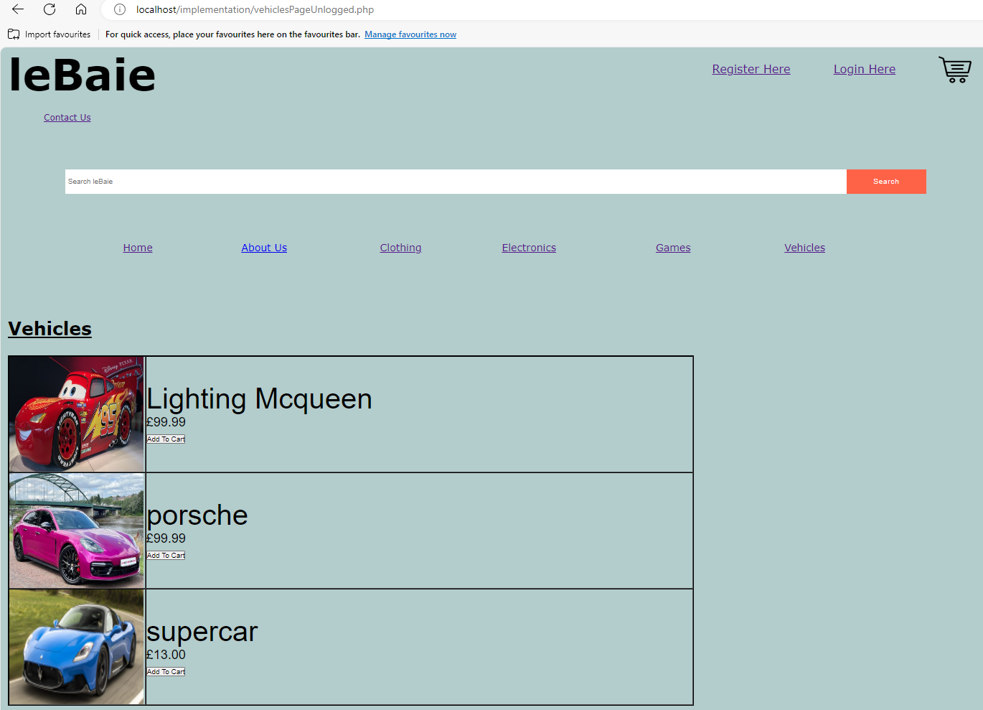

**vehiclePageUnlogged.php code**

<?php

// Start the session

session_start();

?>

<!DOCTYPE html>

<html>

<head>

<title>Lebaie</title>

<link rel="stylesheet" type="text/css" href="css/style.css"> <!-- CSS link -->

</head>

<body>

<!-- Page Header -->

<header>

<h1>leBaie</h1>

<li><a id="regPageID" href="registrationPage.html">Register Here</a></li>

<li><a id="loginPageID" href="loginPage.html">Login Here</a></li>

<li><a id="basketImage" href="basketGuest.php"> <img id="basketImageUnlogged" src="Media/cart.png"> </a></li><br><br><br><br><br><br>

<li><a id="contactUsID" href="contactUsGuest.html">Contact Us</a></li> <br><br><br>

</header>

**vehiclePageUnlogged.php code (2)**

<!-- search bar and search button for unlogged pages-->

<div class="container">

<form id="searchButton" method="GET" action="resultsUnlogged.php">

<input type="text" placeholder="Search leBaie" name="search">

<button type="submit">Search</button>

</form>

</div>

<!-- Navigation Bar -->

<nav>

<ul>

<li><a id="homePageID" href="home.php">Home</a></li>

<li><a href="UnloggedAboutUs.html">About Us</a></li>

<li><a href="clothingPageUnlogged.php">Clothing</a></li>

<li><a href="electronicsPageUnlogged.php">Electronics</a></li>

<li><a href="gamesPageUnlogged.php">Games</a></li>

<li><a href="vehiclesPageUnlogged.php">Vehicles</a></li>

</ul>

</nav>

<main>

<section>

<h2 id="resultsH2">Vehicles</h2>

<br><br><br>

**vehiclePageUnlogged.php code (3)**

<div class="resultsDiv">

<?php

//sets up db

$servername="localhost";

$username="root";

$password="";

$dbname="leBaieBase";

// Create connection

$conn = mysqli_connect($servername, $username, $password, $dbname);

// Check connection

if (!$conn) {

die("Connection failed: " . mysqli_connect_error());

}

//gets values from SQL db table (products) then assigns them to sql

$sql = "SELECT `productName`,`productCategory`, `price`, `image` FROM `products` WHERE `productCategory`='vehicle'";

$result = mysqli_query($conn, $sql);

//querys the db to get all the data for products in the vehicle category

if (mysqli_num_rows($result) > 0) {

echo "<table border='1'>";

**vehiclePageUnlogged.php code (4)**

// output data of each row - uses php variables in order to match users search and concatenate html variables

while($row = mysqli_fetch_assoc($result)) {

$image= $row["image"];

echo "<tr>

<td>". '<img src="media/'.$image.'" class="resultsImage">'. "</td>

<td class='resultsName'>". $row['productName']. '<br> <div class="resP">£' .$row['price']."<br>

<form id='searchButtonRes' method='GET' action='basketProcess.php'>

<button type = 'submit' name = 'cartBtn' Value = ".$row["productName"]. " 'class= 'resultsPageAdd'>Add To Cart</button> </td></div>

</form>

</tr>";}

echo "</table>";}

else {

echo "There were no results matching your search, sorry!";

}

**vehiclePageUnlogged.php code (5)**

mysqli_close($conn);

?>

</div>

</section>

</main>

</body>

</html>

**registration.html**

**code for registration.html**

<!DOCTYPE html>

<html>

<head>

<title>Registration Page</title>

<link rel="stylesheet" type="text/css" href="css/style.css"> <!-- CSS link -->

<script>

function check() {

var input = document.getElementById('password_confirm');

if (input.value != document.getElementById('password').value) {

input.setCustomValidity('Passwords Must be Matching.');

} else {

// input is valid -- reset the error message

input.setCustomValidity('');

}

}

</script>

</head>

<body>

<!-- Page Header -->

<h1 id="regHead">leBaie</h1>

<h3 id="regH2">Create Account</h3>

**code for registration.html (2)**

<div id="regDiv" align="center">

<section id="sectionReg">

<form id="regForm" method="POST" action="process.php">

<p>Username: <input type ="text" size="25" maxlength="10" name="username" value="" required > </p> <br>

<p>First Name: <input type ="text" maxlength="20"size="24" name="firstname" value="" required> </p> <br>

<p>Surname: <input type ="text" maxlength="20" size="26" name="surname" value="" required> </p> <br>

<p>Date of Birth: <input id="DOBreg" type ="date" size="5" name="DOB" value="dd/mm/yyyy" min="1940-12-31" max="2012-12-31" required> </p> <br>

<p> <label for="password">Password:</label> <input name="password" required="required" type="password" id="password" size="26" maxlength="20" oninput="check()"/>

</p> <br>

<p><label for="password_confirm">Confirm Password:</label> <input name="password_confirm" required="required" size="16" type="password" id="password_confirm" maxlength="20" oninput="check()"/>

</p><br>

<button type="submit">Create Account</button>

</form>

**code for registration.html (3)**

<a id="homeRegLink" href="home.php">continue as guest</a>

<a href="loginPage.html">login</a>

</section>

</div>

</body>

</html>

**process.php (page user is taken to after pressing submit on registration page which then redirects user to another page)**

<?php

session_start();

?>

<!DOCTYPE html>

<html>

<?php

$userName = $_POST["username"];

$firstName = $_POST["firstname"];

$surName = $_POST["surname"];

$dateOfBirth = $_POST["DOB"];

$userPassword = $_POST["password"];

$_SESSION["userName"] = $userName;

$_SESSION["firstName"] = $firstName;

$_SESSION["surName"] = $surName;

$_SESSION["dateOfBirth"] = $dateOfBirth;

$_SESSION["userPassword"] = $userPassword;

$servername="localhost";

$username="root";

$password="";

$dbname="leBaieBase";

$conn=mysqli_connect($servername, $username, $password, $dbname);

if (!$conn) {

die("Connection failed: " . mysqli_connect_error()); }

**process.php code (2)**

$result= mysqli_query($conn, "SELECT `username` FROM `registration` WHERE `username`='".$userName."'");

if (mysqli_num_rows($result) >0)

{

echo "<p>Username already exists</p>";

$redirect1 = TRUE;

if ($redirect1) {

header('Location: http://localhost/implementation/failedReg.html');

die();}}

else{

$sql = "INSERT INTO `registration` (`username`,`firstname`,`surname`,`DOB`,`password`)

VALUES('$userName','$firstName','$surName','$dateOfBirth','$userPassword')";

if(mysqli_query($conn, $sql)) {

echo "New account created successfully";}

$redirect = TRUE;

if ($redirect) {

header('Location: http://localhost/implementation/RegisteredHomeLanding.php');

die();}

}?>

</body>

</html>

**RegisteredHome.php with popup on page load**

**RegisteredHome.php when “ok” is pressed on popup**

**Code for registeredHomeLanding.php**

<?php

session_start();

?>

<!DOCTYPE html>

<html>

<head>

<title>Home Page</title>

<link rel="stylesheet" type="text/css" href="css/style.css"> <!-- CSS link -->

<script>

function myFunction() {

alert("Account created/logged in!");}

</script>

</head>

<body onload="myFunction()">

<!-- Page Header -->

<header>

<h1 class="loggedHeader">leBaie</h1>

<li><a id="listProduct" href="listingPage.html">List Product</a></li>

<li><a id="profileImage" href="profile.php"><img id="profileImage" src="media/profile-icon-png-908.png"></a></li>

<li><a id="basketImage" href="basket.php"> <img id="basketImage" src="Media/cart.png"> </a></li><br><br><br><br><br><br>

**Code for registeredHomeLanding.php (2)**

<li><a id="contactUsID" href="contactUs.html">Contact Us</a></li> <br><br><br>

</header>

<!-- search bar and search button for signed in pages -->

<div class="container">

<form id="searchButton" method="GET" action="results.php">

<input type="text" placeholder="Search leBaie" name="search">

<button type="submit">Search</button>

</form>

</div>

<!-- Navigation Bar -->

<nav>

<ul>

<li><a id="homePageID" href="RegisteredHome.php">Home</a></li>

<li><a href="aboutUs.html">About Us</a></li>

<li><a href="clothingPage.php">Clothing</a></li>

<li><a href="electronicsPage.php">Electronics</a></li>

<li><a href="gamesPage.php">Games</a></li>

<li><a href="vehiclesPage.php">Vehicles</a></li>

</ul>

</nav>

<!-- Product of the Month Section-->

<div class="POTM" >

<h2>Our Products of the Month</h2> <br><br>

**Code for registeredHomeLanding.php (3)**

<?php

$servername="localhost";

$username="root";

$password="";

$dbname="leBaieBase";

// Create connection

$conn = mysqli_connect($servername, $username, $password, $dbname);

// Check connection

if (!$conn) {

die("Connection failed: " . mysqli_connect_error());

}

//selects appopriate information from DB that meets conditions

$sql = "SELECT `productName`,`productCategory`, `price`, `image` FROM `products` WHERE `productName`='Modern Warfare 3' or `productName`='Programming Jumper' or

`productName`='Radio'";

$result = mysqli_query($conn, $sql);

echo "<section class='ProdOTM'>";

if (mysqli_num_rows($result) > 0) {

echo "<table border='1'>";

// output data of each row - uses php variables in order to match users search and concatenate html variables

**Code for registeredHomeLanding.php (4)**

while($row = mysqli_fetch_assoc($result)) {

$image= $row["image"];

echo "<tr>

<td>". '<img src="media/'.$image.'" class="resultsImage">'. "</td>

<td class='resultsName'>". $row['productName']. '<br> <div class="resP">£' .$row['price']."<br>

<form id='searchButtonRes' method='GET' action='basketProcess.php'>

<button type = 'submit' name = 'cartBtn' Value = ".$row["productName"]. " 'class= 'resultsPageAdd'>Add To Cart</button> </td></div>

</form>

</tr>";}

echo "</table>";

echo"</section>";}

?>

</div>

</body>

</html>

**aboutUs.html**

**aboutUs.html code**

<!DOCTYPE html>

<html>

<head>

<title>Home Page</title>

<link rel="stylesheet" type="text/css" href="css/style.css"> <!-- CSS link -->

</head>

<body>

<!-- Page Header -->

<header>

<h1 class="loggedHeader">leBaie</h1>

<li><a id="listProduct" href="listingPage.html">List Product</a></li>

<li><a id="profileImage" href="profile.php"><img id="profileImage" src="media/profile-icon-png-908.png"></a></li>

<li><a id="basketImage" href="basket.php"> <img id="basketImage" src="Media/cart.png"> </a></li><br><br><br><br><br><br>

<li><a id="contactUsID" href="contactUs.html">Contact Us</a></li> <br><br><br>

</header>

<!-- search bar and search button for signed in pages -->

<div class="container">

<form id="searchButton" method="GET" action="results.php">

<input type="text" placeholder="Search leBaie">

<button type="submit">Search</button>

**aboutUs.html code (2)**

</form>

</div>

<!-- Navigation Bar -->

<nav>

<ul>

<li><a id="homePageID" href="RegisteredHome.php">Home</a></li>

<li><a href="aboutUs.html">About Us</a></li>

<li><a href="clothingPage.php">Clothing</a></li>

<li><a href="electronicsPage.php">Electronics</a></li>

<li><a href="gamesPage.php">Games</a></li>

<li><a href="vehiclesPage.php">Vehicles</a></li>

</ul>

</nav>

<h3 class="aboutUs">About Us</h3>

<section class="aboutSection">

<img src="Media/me.jpeg" alt="sigma" class="me">

<p class="aboutTxt">Here at Lebaie we connect people and build communities to create a opportunity for all. At leBaie, we create pathways to connect sellers and buyers.

Lebaie empowers our customers, providing everyone the opportunity to grow, no matter who they are or where they are.

And the ripple effect of our work creates waves of change for our customers, our company, our communities and our planet. Lebaie is a store by the people, for the people <br>

**aboutUs.html code (3)**

<br> Furthermore, we will be sending our code for review as we are dedicated to being as transparent

as possible. After carefully reviewing over every line contained in our program,a determination will be made decide to what extent leBaie has the qualities

it requires to suceed.

</p>

</section>

<br>

<br>

<br>

</body>

</html>

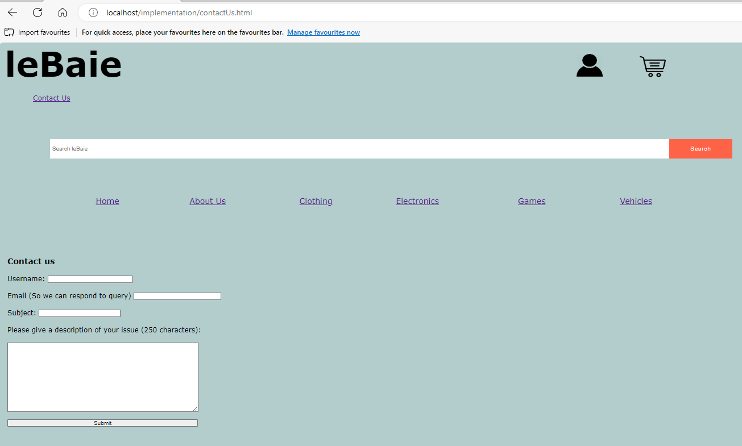**contactUs.html**

**contactUs.html code**

<!DOCTYPE html>

<html>

<head>

<title>Home Page</title>

<link rel="stylesheet" type="text/css" href="css/style.css"> <!-- CSS link -->

</head>

<body>

<!-- Page Header -->

<header>

<h1 class="loggedHeader">leBaie</h1>

<li><a id="profileImage" href="profile.php"><img id="profileImage" src="media/profile-icon-png-908.png"></a></li>

<li><a id="basketImage" href="basket.php"> <img id="basketImage" src="Media/cart.png"> </a></li><br><br><br><br><br><br>

<li><a id="contactUsID" href="contactUs.html">Contact Us</a></li> <br><br><br>

</header>

<!-- search bar and search button for signed in pages -->

<div class="container">

<form id="searchButton" method="GET" action="results.php">

<input type="text" placeholder="Search leBaie">

<button type="submit">Search</button>

</form>

</div>

<!-- Navigation Bar -->

<nav>

<ul>

<li><a id="homePageID" href="RegisteredHome.php">Home</a></li>

<li><a href="aboutUs.html">About Us</a></li>

<li><a href="clothingPage.php">Clothing</a></li>

<li><a href="electronicsPage.php">Electronics</a></li>

<li><a href="gamesPage.php">Games</a></li>

<li><a href="vehiclesPage.php">Vehicles</a></li>

</ul>

</nav>

**contactUs.html code (2)**

<h3 id="contactHeader">Contact us</h3>

<form id="contactForm" method="get" action="customerQuery.php">

<p>Username: <input type ="text" size="25" maxlength="10" name="username" value=""> </p> <br>

<p>Email (So we can respond to query) <input type ="text" maxlength="30" size="26" name="email" value="" required> </p> <br>

<p>Subject: <input type ="text" maxlength="30"size="24" name="subject" value="" required> </p> <br>

<P>Please give a description of your issue (250 characters):</P><br>

<textarea name="issue" rows="10" cols="58"> </textarea> <br>

<button type="submit" id="contactSubmit">Submit </button>

</form>

</body>

</html>

**Code for customerQuery.php**

<!DOCTYPE html>

<html>

<?php

session_start();

$userName = $_GET["username"];

$email = $_GET["email"];

$subject = $_GET["subject"];

$issueDes = $_GET["issue"];

$servername="localhost";

$username="root";

$password="";

$dbname="leBaieBase";

$conn=mysqli_connect($servername, $username, $password, $dbname);

if (!$conn) {

die("Connection failed: " . mysqli_connect_error()); }

$result= mysqli_query($conn, "SELECT `username` FROM `registration` WHERE `username`='".$userName."'");

$sql = "INSERT INTO `contactUs` (`username`,`email`,`subject`,`issueDescription`)

VALUES('$userName','$email','$subject','$issueDes')";

if(mysqli_query($conn, $sql)){

if (mysqli_num_rows($result) >0)

{ $redirect = TRUE;

if ($redirect) {

header('Location: http://localhost/implementation/RegisteredHomeContact.php');

die();}}

else{ $redirect1 = TRUE;

if ($redirect1) {

header('Location: http://localhost/implementation/homeContact.php');

die();}}}

?>

</body>

</html>

**RegisteredHomeContact.php with on load message**

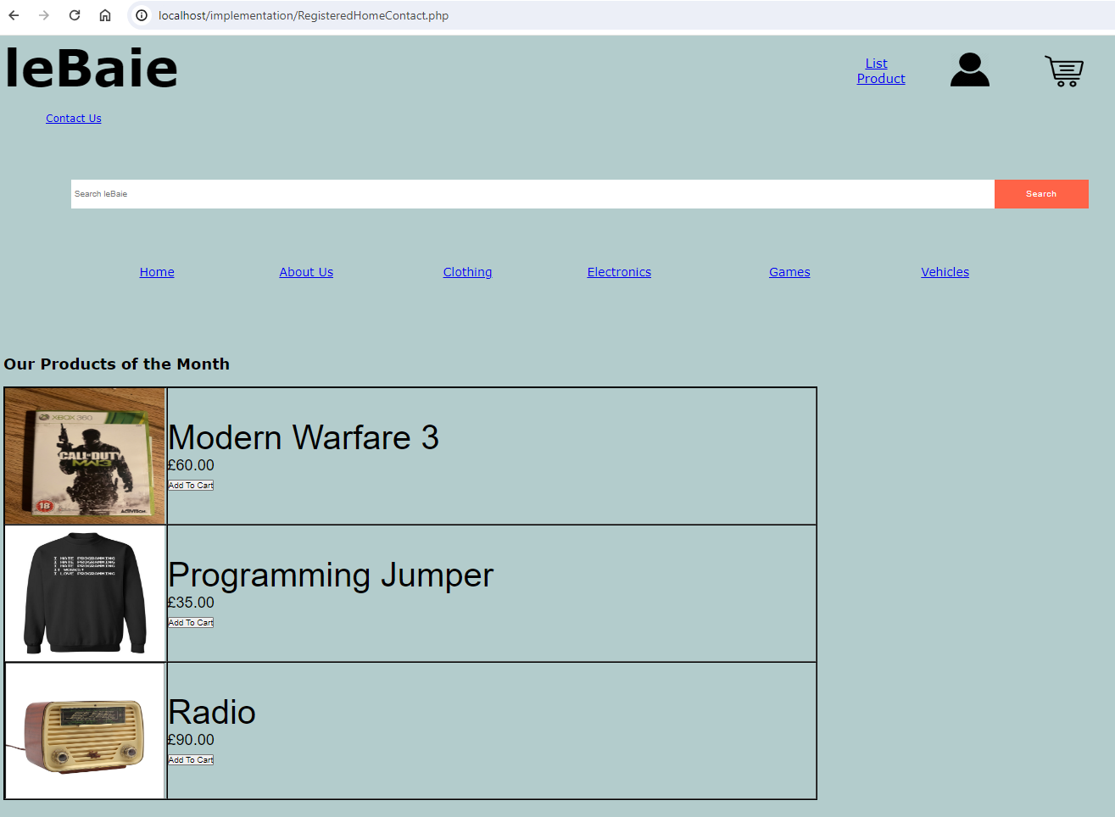**RegisteredHomeContact.php when ok is pressed**

**RegisteredHomeContact.php code**

<?php

session_start();

?>

<!DOCTYPE html>

<html>

<head>

<title>Home Page</title>

<link rel="stylesheet" type="text/css" href="css/style.css"> <!-- CSS link -->

<script>

function myFunction() {

alert("Query Submitted!");}

</script>

</head>

<body onload="myFunction()">

<!-- Page Header -->

<header>

<h1 class="loggedHeader">leBaie</h1>

<li><a id="listProduct" href="listingPage.html">List Product</a></li>

<li><a id="profileImage" href="profile.php"><img id="profileImage" src="media/profile-icon-png-908.png"></a></li>

<li><a id="basketImage" href="basket.php"> <img id="basketImage" src="Media/cart.png"> </a></li><br><br><br><br><br><br>

<li><a id="contactUsID" href="contactUs.html">Contact Us</a></li> <br><br><br>

</header>

<!-- search bar and search button for signed in pages -->

<div class="container">

<form id="searchButton" method="GET" action="results.php">

<input type="text" placeholder="Search leBaie" name="search">

<button type="submit">Search</button>

</form>

</div>

<!-- Navigation Bar -->

**RegisteredHomeContact.php code (2)**

<nav>

<ul>

<li><a id="homePageID" href="RegisteredHome.php">Home</a></li>

<li><a href="aboutUs.html">About Us</a></li>

<li><a href="clothingPage.php">Clothing</a></li>

<li><a href="electronicsPage.php">Electronics</a></li>

<li><a href="gamesPage.php">Games</a></li>

<li><a href="vehiclesPage.php">Vehicles</a></li>

</ul>

</nav>

<!-- Product of the Month Section-->

<div class="POTM" >

<h2>Our Products of the Month</h2> <br><br>

<?php

$servername="localhost";

$username="root";

$password="";

$dbname="leBaieBase";

// Create connection

$conn = mysqli_connect($servername, $username, $password, $dbname);

// Check connection

if (!$conn) {

die("Connection failed: " . mysqli_connect_error());

}

//selects appopriate information from DB that meets conditions

$sql = "SELECT `productName`,`productCategory`, `price`, `image` FROM `products` WHERE `productName`='Modern Warfare 3' or `productName`='Programming Jumper' or

`productName`='Radio'";

$result = mysqli_query($conn, $sql);

echo "<section class='ProdOTM'>";

if (mysqli_num_rows($result) > 0) {

echo "<table border='1'>";

**RegisteredHomeContact.php code (3)**

// output data of each row - uses php variables in order to match users search and concatenate html variables

while($row = mysqli_fetch_assoc($result)) {

$image= $row["image"];

echo "<tr>

<td>". '<img src="media/'.$image.'" class="resultsImage">'. "</td>

<td class='resultsName'>". $row['productName']. '<br> <div class="resP">£' .$row['price']."<br>

<form id='searchButtonRes' method='GET' action='basketProcess.php'>

<button type = 'submit' name = 'cartBtn' Value = ".$row["productName"]. " 'class= 'resultsPageAdd'>Add To Cart</button> </td></div>

</form>

</tr>";}

echo "</table>";

echo"</section>";}

?>

</div>

</body>

</html>

**listingPage.html**

**listingPage.html code**

<!DOCTYPE html>

<html>

<head>

<title>Listing Page</title>

<link rel="stylesheet" type="text/css" href="css/style.css"> <!-- CSS link -->

</head>

<body>

<!-- Page Header -->

<header>

<h1 class="loggedHeader">leBaie</h1>

<li><a id="profileImage" href="profile.html"><img id="profileImage" src="media/profile-icon-png-908.png"></a></li>

<li><a id="basketImage" href="basket.php"> <img id="basketImage" src="Media/cart.png"> </a></li><br><br><br><br><br><br>

<li><a id="contactUsID" href="contactUs.html">Contact Us</a></li> <br><br><br>

</header>

<!-- Navigation Bar -->

<nav id="listingNav">

<nav>

<ul>

<li><a id="homePageID" href="RegisteredHome.php">Home</a></li>

<li><a href="aboutUs.html">About Us</a></li>

<li><a href="clothingPage.php">Clothing</a></li>

<li><a href="electronicsPage.php">Electronics</a></li>

<li><a href="gamesPage.php">Games</a></li>

<li><a href="vehiclesPage.php">Vehicles</a></li>

</ul>

</nav>

<form id="listingForm" method="get" action="listing.php">

<p>Product Name <input type ="text" size="25" maxlength="20" name="productname" value="" required > </p> <br>

<br>

**listingPage.html code (2)**

Product Category: <select id="productCat" name="category" required >

<option value=""></option>

<option value="electronics">Electronics</option>

<option value="vehicle">Vehicle</option>

<option value="instrument">Instrument</option>

<option value="clothing">Clothing</option>

<option value="games">Games</option>

<option value="other">Other</option>

</select>

<br><br>

<p>Price: <input type ="number" min="00.00" max="100000" name="price" value="00.00" required> </p> <br>

Select Image File:

<input type="file" id="fileListing" name="image" size="40" required> <br> <br>

<input type="submit" id="listingSubmit" name="submit" size="40" value="create listing">

</form>

</body>

</html>

**listing.php code (page taken to after pressing create listing, it then redirects user)**

<!DOCTYPE html>

<html>

<?php

session_start();

$userProduct = $_GET["productname"];

$itemCategory = $_GET["category"];

$price = $_GET["price"];

$image = $_GET["image"];

$servername="localhost";

$username="root";

$password="";

$dbname="leBaieBase";

$conn=mysqli_connect($servername, $username, $password, $dbname);

if (!$conn) {

die("Connection failed: " . mysqli_connect_error()); }

$sql = "INSERT INTO `products` (`productName`,`productCategory`,`price`,`image`)

VALUES('$userProduct','$itemCategory','$price','$image')";

if(mysqli_query($conn, $sql)) {

echo "Product Listed";}

$redirect = TRUE;

if ($redirect) {

header('Location: http://localhost/implementation/RegisteredHome.php');

die();}

else{

echo "<p>Error Registering Account</p>";

}

?>

</html>

**basket.php**

**basket.php when basket is empty**

**code for basket.php**

<?php

// Start the session

session_start();

?>

<!DOCTYPE html>

<html>

<head>

<title>Lebaie</title>

<link rel="stylesheet" type="text/css" href="css/style.css"> <!-- CSS link -->

</head>

<body>

<header>

<h1 class="loggedHeader">leBaie</h1>

<li><a id="listProduct" href="listingPage.html">List Product</a></li>

<li><a id="profileImage" href="profile.php"><img id="profileImage" src="media/profile-icon-png-908.png"></a></li>

<li><a id="basketImage" href="basket.php"> <img id="basketImage" src="Media/cart.png"> </a></li><br><br><br><br><br><br>

<li><a id="contactUsID" href="contactUs.html">Contact Us</a></li> <br><br><br>

</header>

**code for basket.php (2)**

<!-- Navigation Bar -->

<nav>

<ul>

<li><a id="homePageID" href="RegisteredHome.php">Home</a></li>

<li><a href="aboutUs.html">About Us</a></li>

<li><a href="clothingPage.php">Clothing</a></li>

<li><a href="electronicsPage.php">Electronics</a></li>

<li><a href="gamesPage.php">Games</a></li>

<li><a href="vehiclesPage.php">Vehicles</a></li>

</ul>

</nav>

<main>

<section>

<h2 id="resultsH2">Basket</h2>

<br><br><br>

<div class="resultsDiv">

<?php

$uname = $_SESSION["userName"];

$servername="localhost";

$username="root";

$password="";

$dbname="leBaieBase";

**code for basket.php (3)**

// Create connection

$conn = mysqli_connect($servername, $username, $password, $dbname);

// Check connection

if (!$conn) {

die("Connection failed: " . mysqli_connect_error());

}

$sql = "SELECT `productBasket`,`basketCategory`,`basPrice`,`uname`, `image` FROM `basket` WHERE `uname` = '$uname'";

$result = mysqli_query($conn, $sql);

if (mysqli_num_rows($result) > 0) {

echo "<table border='1'>";

// output data of each row - uses php variables in order to match users search and concatenate html variables

while($row = mysqli_fetch_assoc($result)) {

$image= $row["image"];

echo "<tr>

<td>". '<img src="media/'.$image.'" class="resultsImage">'. "</td>

**code for basket.php (4)**

<td class='resultsName'>". $row['productBasket']. '<br> <div class="resP">£' .$row['basPrice']."<br>

<form id='searchButtonRes' method='GET' action='basketRemove.php'>

<button type = 'submit' name = 'removeBtn' Value = ".$row["productBasket"]. " 'class= 'resultsButton'>Remove from basket</button> </td></div>

</form>

</tr>";}

echo "</table>";

echo "<br>";

echo "<button type='submit' class='basketButton'>Checkout </button>";}

else {

echo "Your Basket is empty, sorry!";

}

mysqli_close($conn);

?>

</div>

</section>

</main>

</body>

</html**>**

**basketProcess.php (which redirects user on pageload) and occurs when add to basket is clicked**

<?php

// Start the session

session_start();

$servername="localhost";

$username="root";

$password="";

$dbname="leBaieBase";

$userBasket=$_GET["cartBtn"];

// Create connection

$conn = mysqli_connect($servername, $username, $password, $dbname);

// Check connection

if (!$conn) {

die("Connection failed: " . mysqli_connect_error());

}

$sql = "SELECT `productName`,`productCategory`, `price`, `image` FROM `products` WHERE `productName` like '%$userBasket%'";

$result = mysqli_query($conn, $sql);

if (mysqli_num_rows($result) > 0) {

//sets $result to $row which is a associated array which is then inserted to basket table

$row =mysqli_fetch_array($result);

$uname = $_SESSION["userName"];

$prod = $row["productName"];

$basCat = $row["productCategory"];

$price = $row["price"];

$image =$row["image"];

**basketProcess.php code (2)**

$sql = "INSERT INTO `basket` (`productBasket`,`basketCategory`,`basPrice`,`uname`, `image`)

VALUES('$prod','$basCat','$price','$uname','$image')";

//querys db and creates delay so that insert works before being redirected to the page they came from

if(mysqli_query($conn, $sql)) {

echo "added to basket";}

$redirect1 = TRUE;

if ($redirect1) {

header('Location: ' . $_SERVER['HTTP_REFERER']);

die();}}

else{echo"error adding to basket";}

mysqli_close($conn);

?>

**basketRemove.php (redirects user after remove from basket button is clicked)**

<?php

// Start the session

session_start();

$prod = $_GET["removeBtn"];

$uname = $_SESSION["userName"];

$servername="localhost";

$username="root";

$password="";

$dbname="leBaieBase";

// Create connection

$conn = mysqli_connect($servername, $username, $password, $dbname);

// Check connection

if (!$conn) {

die("Connection failed: " . mysqli_connect_error()); }

// sql to delete a record of product selected

$sql = "DELETE FROM `basket` WHERE `productBasket` like '%$prod%'";

if (mysqli_query($conn, $sql)) {

echo "Record deleted successfully";#

$redirect1 = TRUE;

if ($redirect1) {

header('Location: http://localhost/implementation/basket.php');

die();}

else{echo"error adding to basket";}}

else {

echo "Error deleting record: " . mysqli_error($conn);

}

mysqli_close($conn);

?>

</div>

</section>

</main>

</body>

</html>

**RegisteredHome.php**

**RegisteredHome.php code**

<?php

session_start();

?>

<!DOCTYPE html>

<html>

<head>

<title>Home Page</title>

<link rel="stylesheet" type="text/css" href="css/style.css"> <!-- CSS link -->

<script>

</script>

</head>

<body>

<!-- Page Header -->

<header>

<h1 class="loggedHeader">leBaie</h1>

<li><a id="listProduct" href="listingPage.html">List Product</a></li>

<li><a id="profileImage" href="profile.php"><img id="profileImage" src="media/profile-icon-png-908.png"></a></li>

<li><a id="basketImage" href="basket.php"> <img id="basketImage" src="Media/cart.png"> </a></li><br><br><br><br><br><br>

<li><a id="contactUsID" href="contactUs.html">Contact Us</a></li> <br><br><br>

**RegisteredHome.php code (2)**

</header>

<!-- search bar and search button for signed in pages -->

<div class="container">

<form id="searchButton" method="GET" action="results.php">

<input type="text" placeholder="Search leBaie" name="search">

<button type="submit">Search</button>

</form>

</div>

<!-- Navigation Bar -->

<nav>

<ul>

<li><a id="homePageID" href="RegisteredHome.php">Home</a></li>

<li><a href="aboutUs.html">About Us</a></li>

<li><a href="clothingPage.php">Clothing</a></li>

<li><a href="electronicsPage.php">Electronics</a></li>

<li><a href="gamesPage.php">Games</a></li>

<li><a href="vehiclesPage.php">Vehicles</a></li>

</ul>

</nav>

<!-- Product of the Month Section-->

<div class="POTM" >

<h2>Our Products of the Month</h2> <br><br>

**RegisteredHome.php code (3)**

<?php

$servername="localhost";

$username="root";

$password="";

$dbname="leBaieBase";

// Create connection

$conn = mysqli_connect($servername, $username, $password, $dbname);

// Check connection

if (!$conn) {

die("Connection failed: " . mysqli_connect_error());

}

//selects appopriate information from DB that meets conditions

$sql = "SELECT `productName`,`productCategory`, `price`, `image` FROM `products` WHERE `productName`='Modern Warfare 3' or `productName`='Programming Jumper' or

`productName`='Radio'";

$result = mysqli_query($conn, $sql);

echo "<section class='ProdOTM'>";

if (mysqli_num_rows($result) > 0) {

echo "<table border='1'>";

// output data of each row - uses php variables in order to match users search and concatenate html variables

**RegisteredHome.php code (4)**

while($row = mysqli_fetch_assoc($result)) {

$image= $row["image"];

echo "<tr>

<td>". '<img src="media/'.$image.'" class="resultsImage">'. "</td>

<td class='resultsName'>". $row['productName']. '<br> <div class="resP">£' .$row['price']."<br>

<form id='searchButtonRes' method='GET' action='basketProcess.php'>

<button type = 'submit' name = 'cartBtn' Value = ".$row["productName"]. " 'class= 'resultsPageAdd'>Add To Cart</button> </td></div>

</form>

</tr>";}

echo "</table>";

echo"</section>";}

?>

</div>

</body>

</html>

﻿﻿**clothingPage.php**

**clothingPage.php code**

<?php

// Start the session

session_start();

?>

<!DOCTYPE html>

<html>

<head>

<title>Lebaie</title>

<link rel="stylesheet" type="text/css" href="css/style.css"> <!-- CSS link -->

</head>

<body>

<header>

<h1 class="loggedHeader">leBaie</h1>

<li><a id="listProduct" href="listingPage.html">List Product</a></li>

<li><a id="profileImage" href="profile.php"><img id="profileImage" src="media/profile-icon-png-908.png"></a></li>

<li><a id="basketImage" href="basket.php"> <img id="basketImage" src="Media/cart.png"> </a></li><br><br><br><br><br><br>

<li><a id="contactUsID" href="contactUs.html">Contact Us</a></li> <br><br><br>

</header>

<!-- search bar and search button for signed in pages -->

<div class="container">

<form id="searchButton" method="GET" action="results.php">

<input type="text" placeholder="Search leBaie" name="search">

<button type="submit">Search</button>

</form>

</div>

<!-- Navigation Bar -->

<nav>

<ul>

<li><a id="homePageID" href="RegisteredHome.php">Home</a></li>

<li><a href="aboutUs.html">About Us</a></li>

<li><a href="clothingPage.php">Clothing</a></li>

<li><a href="electronicsPage.php">Electronics</a></li>

**clothingPage.php code (2)**

<li><a href="gamesPage.php">Games</a></li>

<li><a href="vehiclesPage.php">Vehicles</a></li>

</ul>

</nav>

<main>

<section>

<h2 id="resultsH2">Clothing</h2>

<br><br><br>

<div class="resultsDiv">

<?php

//sets up db

$servername="localhost";

$username="root";

$password="";

$dbname="leBaieBase";

// Create connection

$conn = mysqli_connect($servername, $username, $password, $dbname);

// Check connection

if (!$conn) {

die("Connection failed: " . mysqli_connect_error());

}

//selects data from db thats in the cloting category then assigns to php variable

$sql = "SELECT `productName`,`productCategory`, `price`, `image` FROM `products` WHERE `productCategory`='Clothing'";

$result = mysqli_query($conn, $sql);

if (mysqli_num_rows($result) > 0) {

echo "<table border='1'>";

// output data of each row - uses php variables in order to match users search and concatenate html variables

while($row = mysqli_fetch_assoc($result)) {

**clothingPage.php code (3)**

$image= $row["image"];

echo "<tr>

<td>". '<img src="media/'.$image.'" class="resultsImage">'. "</td>

<td class='resultsName'>". $row['productName']. '<br> <div class="resP">£' .$row['price']."<br>

<form id='searchButtonRes' method='GET' action='basketProcess.php'>

<button type = 'submit' name = 'cartBtn' Value = ".$row["productName"]. " 'class= 'resultsPageAdd'>Add To Cart</button> </td></div>

</form>

</tr>";}

echo "</table>";}

else {

echo "There were no results matching your search, sorry!";

}

mysqli_close($conn);

?>

</div>

</section>

</main>

</body>

</html>

**electronicsPage.php**

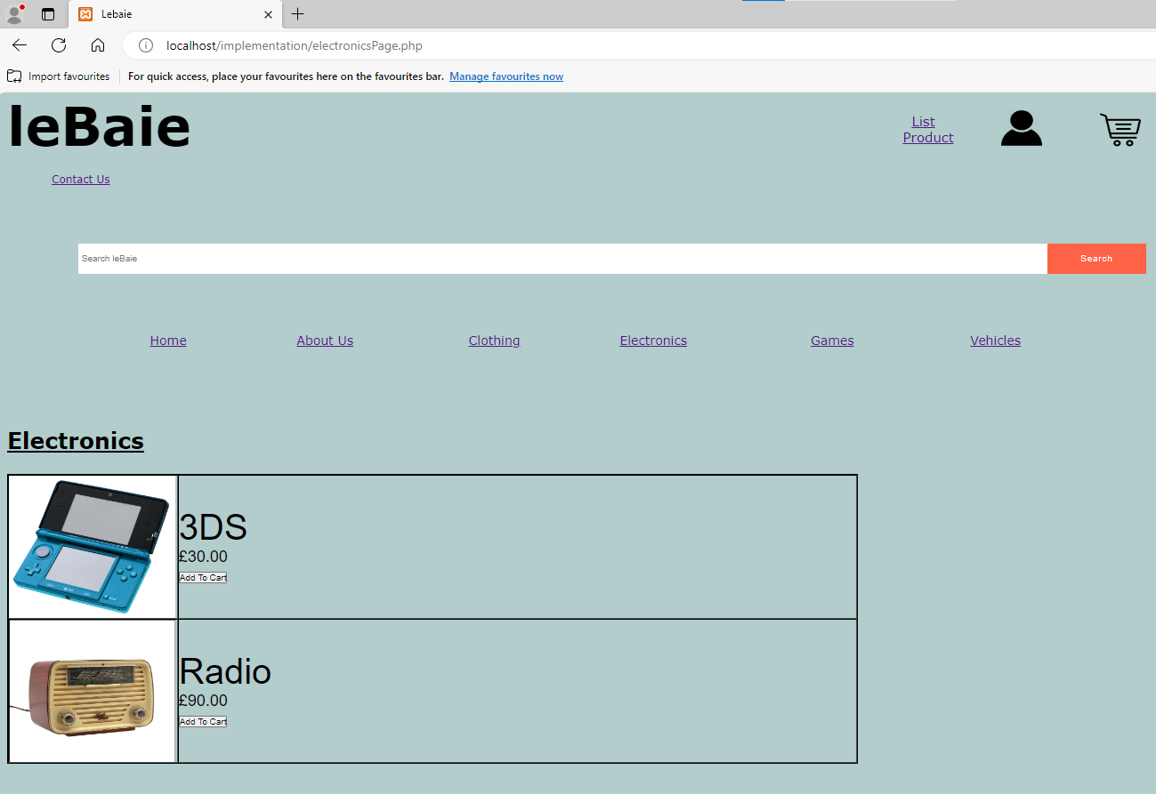

**electronicsPage.php code**

<?php

// Start the session

session_start();

?>

<!DOCTYPE html>

<html>

<head>

<title>Lebaie</title>

<link rel="stylesheet" type="text/css" href="css/style.css"> <!-- CSS link -->

</head>

<body>

<header>

<h1 class="loggedHeader">leBaie</h1>

<li><a id="listProduct" href="listingPage.html">List Product</a></li>

<li><a id="profileImage" href="profile.php"><img id="profileImage" src="media/profile-icon-png-908.png"></a></li>

<li><a id="basketImage" href="basket.php"> <img id="basketImage" src="Media/cart.png"> </a></li><br><br><br><br><br><br>

<li><a id="contactUsID" href="contactUs.html">Contact Us</a></li> <br><br><br>

</header>

<!-- search bar and search button for signed in pages -->

<div class="container">

<form id="searchButton" method="GET" action="results.php">

<input type="text" placeholder="Search leBaie" name="search">

<button type="submit">Search</button>

</form>

</div>

<!-- Navigation Bar -->

<nav>

<ul>

<li><a id="homePageID" href="RegisteredHome.php">Home</a></li>

<li><a href="aboutUs.html">About Us</a></li>

<li><a href="clothingPage.php">Clothing</a></li>

**electronicsPage.php code (2)**

<li><a href="electronicsPage.php">Electronics</a></li>

<li><a href="gamesPage.php">Games</a></li>

<li><a href="vehiclesPage.php">Vehicles</a></li>

</ul>

</nav>

<main>

<section>

<h2 id="resultsH2">Electronics</h2>

<br><br><br>

<div class="resultsDiv">

<?php

$servername="localhost";

$username="root";

$password="";

$dbname="leBaieBase";

// Create connection

$conn = mysqli_connect($servername, $username, $password, $dbname);

// Check connection

if (!$conn) {

die("Connection failed: " . mysqli_connect_error());

}

$sql = "SELECT `productName`,`productCategory`, `price`, `image` FROM `products` WHERE `productCategory`='electronics'";

$result = mysqli_query($conn, $sql);

if (mysqli_num_rows($result) > 0) {

echo "<table border='1'>";

// output data of each row - uses php variables in order to match users search and concatenate html variables

while($row = mysqli_fetch_assoc($result)) {

**electronicsPage.php code (3)**

$image= $row["image"];

echo "<tr>

<td>". '<img src="media/'.$image.'" class="resultsImage">'. "</td>

<td class='resultsName'>". $row['productName']. '<br> <div class="resP">£' .$row['price']."<br>

<form id='searchButtonRes' method='GET' action='basketProcess.php'>

<button type = 'submit' name = 'cartBtn' Value = ".$row["productName"]. " 'class= 'resultsPageAdd'>Add To Cart</button> </td></div>

</form>

</tr>";}

echo "</table>";}

else {

echo "There were no results matching your search, sorry!";

}

mysqli_close($conn);

?>

</div>

</section>

</main>

</body>

</html>

**gamesPage.php**

**games.php code (1)**

<?php

// Start the session

session_start();

?>

<!DOCTYPE html>

<html>

<head>

<title>Lebaie</title>

<link rel="stylesheet" type="text/css" href="css/style.css"> <!-- CSS link -->

</head>

<body>

<header>

<h1 class="loggedHeader">leBaie</h1>

<li><a id="listProduct" href="listingPage.html">List Product</a></li>

<li><a id="profileImage" href="profile.php"><img id="profileImage" src="media/profile-icon-png-908.png"></a></li>

<li><a id="basketImage" href="basket.php"> <img id="basketImage" src="Media/cart.png"> </a></li><br><br><br><br><br><br>

<li><a id="contactUsID" href="contactUs.html">Contact Us</a></li> <br><br><br>

</header>

<!-- search bar and search button for signed in pages -->

<div class="container">

<form id="searchButton" method="GET" action="results.php">

<input type="text" placeholder="Search leBaie" name="search">

<button type="submit">Search</button>

</form>

</div>

<!-- Navigation Bar -->

<nav>

<ul>

<li><a id="homePageID" href="RegisteredHome.php">Home</a></li>

<li><a href="aboutUs.html">About Us</a></li>

<li><a href="clothingPage.php">Clothing</a></li>

<li><a href="electronicsPage.php">Electronics</a></li>

**games.php code (2)**

<li><a href="gamesPage.php">Games</a></li>

<li><a href="vehiclesPage.php">Vehicles</a></li>

</ul>

</nav>

<main>

<section>

<h2 id="resultsH2">Games</h2>

<br><br><br>

<div class="resultsDiv">

<?php

$servername="localhost";

$username="root";

$password="";

$dbname="leBaieBase";

// Create connection

$conn = mysqli_connect($servername, $username, $password, $dbname);

// Check connection

if (!$conn) {

die("Connection failed: " . mysqli_connect_error());

}

//connects to db and assigns values from products table

$sql = "SELECT `productName`,`productCategory`, `price`, `image` FROM `products` WHERE `productCategory`='games'";

$result = mysqli_query($conn, $sql);

//repeats for each bit of data thats being displayed in the table

if (mysqli_num_rows($result) > 0) {

echo "<table border='1'>";

// output data of each row - uses php variables in order to match users search and concatenate html variables

**games.php code (3)**

while($row = mysqli_fetch_assoc($result)) {

$image= $row["image"];

//sets up the parameters for information inside the table using html and php variables that were assigned above

echo "<tr>

<td>". '<img src="media/'.$image.'" class="resultsImage">'. "</td>

<td class='resultsName'>". $row['productName']. '<br> <div class="resP">£' .$row['price']."<br>

<form id='searchButtonRes' method='GET' action='basketProcess.php'>

<button type = 'submit' name = 'cartBtn' Value = ".$row["productName"]. " 'class= 'resultsPageAdd'>Add To Cart</button> </td></div>

</form>

</tr>";}

echo "</table>";}

else {

echo "There were no results matching your search, sorry!";

}

mysqli_close($conn);

?>

</div>

</section>

</main>

</body>

</html>

﻿﻿**profile.php**

**Code for profile.php**

<?php

session_start();

?>

<!DOCTYPE html>

<html>

<head>

<title>Profile Page</title>

<link rel="stylesheet" type="text/css" href="css/style.css"> <!-- CSS link -->

</head>

<body>

<header>

<h1 id="profileH1">leBaie</h1>

<li><a id="LogOut" href="logout.php">Log Out</a></li>

</header>

<!-- Navigation Bar -->

<nav>

<ul>

<li><a id="homePageID" href="RegisteredHome.php">Home</a></li>

<li><a href="aboutUs.html">About Us</a></li>

<li><a href="clothingPage.php">Clothing</a></li>

<li><a href="electronicsPage.php">Electronics</a></li>

<li><a href="gamesPage.php">Games</a></li>

<li><a href="vehiclesPage.php">Vehicles</a></li>

</ul>

</nav>

<?php

$uname = $_SESSION["userName"];

$forename = $_SESSION["firstName"];

$surname = $_SESSION["surName"] ;

$dob = $_SESSION["dateOfBirth"];

$pass = $_SESSION["userPassword"];

$servername="localhost";

$username="root";

$password="";

**Code for profile.php (2)**

$dbname="leBaieBase";

$conn=mysqli_connect($servername, $username, $password, $dbname);

//if session variable is set, display users details using php variables

if (isset($_SESSION["firstName"])){

echo "<h2 id='profileHeading'>Heres a look at your profile ".$forename."</h2>";

echo"<section class='profileInfo'>";

echo"<br>";

echo "<p>Username: ".$uname."</p>";

echo"<br>";

echo "<p>Forename: ".$forename."</p>";

echo"<br>";

echo "<p>Surname: ".$surname."</p>";

echo"<br>";

echo "<p>DOB: ".$dob."</p>";

echo"<br>";

echo "<p>password: ".$pass."</p>";

echo"</section>";

echo"<br>";

echo "<form action='editProfile.php'>";

echo "<button id=editButton type='submit'>Edit Profile </button>";

echo "</form>";

}

?>

</body>

</html>

**logout.php**

<?php

//destroys all of the data associated with the current session.

session_destroy();

echo "<h2>Log Out</h2>";

echo "<p>You have been logged out</p>";

echo "<p><a href='home.php'>Return to login screen</a></p>";

//redirects user to home page for guests

$redirect1 = TRUE;

if ($redirect1) {

header('Location: http://localhost/implementation/home.php');

die();}

?>

**editProfile.php**

**editProfile.php code**

<?php

session_start();

?>

<!DOCTYPE html>

<html>

<head>

<title>Profile Page</title>

<link rel="stylesheet" type="text/css" href="css/style.css"> <!-- CSS link -->

</head>

<body>

<header>

<h1 id="profileH1">leBaie</h1>

</header>

<!-- Navigation Bar -->

<nav>

<ul>

<li><a id="homePageID" href="RegisteredHome.php">Home</a></li>

<li><a href="aboutUs.html">About Us</a></li>

<li><a href="clothingPage.php">Clothing</a></li>

<li><a href="electronicsPage.php">Electronics</a></li>

<li><a href="gamesPage.php">Games</a></li>

<li><a href="vehiclesPage.php">Vehicles</a></li>

</ul>

</nav>

//assigns serverside variables to session variable values

<?php

$uname = $_SESSION["userName"];

$forename = $_SESSION["firstName"];

$surname = $_SESSION["surName"] ;

$dob = $_SESSION["dateOfBirth"];

$pass = $_SESSION["userPassword"];

$servername="localhost";

$username="root";

$password="";

$dbname="leBaieBase";

$conn=mysqli_connect($servername, $username, $password, $dbname);

?>

**editProfile.php code (2)**

//use session variables to store users info to then display it on a html form

<h2 id='profileHeading'>Edit Profile:</h2>

<section class="profileInfo">

<form id="profileEdits" method="POST" action="updateProfile.php">

<br><br><br><br><br>

<p>Forename: <input type ="text" maxlength="20"size="25" name="updateForename" required value="<?php echo $forename;?>"/> </p> <br>

<p>Surname: <input type ="text" maxlength="20"size="24" name="updateSurname" required value="<?php echo $surname;?>"/> </p> <br>

<p>Date of Birth: <input type ="date" name="updateDOB" min="1940-12-31" max="2012-12-31" required value="<?php echo $dob;?>"/> </p> <br>

<p>Password: <input type ="text" maxlength="20" size="26" name="updatePass" required value="<?php echo $pass;?>"/> </p> <br>

<button id="saveProfile" type="submit">Save Changes</button>

</form>

</section>

</body>

</html>

**UpdateProfile.php**

<?php

session_start();

?>

<!DOCTYPE html>

<html>

<?php

//gets users input from forms using post method and uses session variable from login or registration page to assign value to uname

$uname = $_SESSION["userName"];

$updateForename = $_POST["updateForename"];

$updateSurname = $_POST["updateSurname"];

$updateDOB = $_POST["updateDOB"];

$updatePass = $_POST["updatePass"];

$servername="localhost";

$username="root";

$password="";

$dbname="leBaieBase";

//connects to db

$conn=mysqli_connect($servername, $username, $password, $dbname);

//checks to see if db sucessfully connected

if (!$conn) {

die("Connection failed: " . mysqli_connect_error());

}

//updates the users details in the SQL db table "registration"

$sql = "UPDATE `registration` SET `firstname` = '$updateForename', `surname` = '$updateSurname', `DOB` = $updateDOB, `password` = '$updatePass' WHERE `username` = '$uname'";

echo $sql;

//querys the db update the users details

if(mysqli_query($conn, $sql)) {

echo "Account updated successfully";}

//sets up session variables to be used across website

$_SESSION["firstName"] = $updateForename;

$_SESSION["surName"] = $updateSurname;

$_SESSION["dateOfBirth"] = $updateDOB;

**UpdateProfile.php code (2)**

$_SESSION["userPassword"] = $updatePass;

//setups redirect, which then sends user to the profile page after there details have updated

$redirect = TRUE;

if ($redirect) {

header('Location: http://localhost/implementation/profile.php');

die();

}

mysqli_close($conn)

?>

</body>

</html>

**BasketProcessGuest.php (carries out process of adding guests’ item into basket, redirects user when page loads)**

<?php

// Start the session

session_start();

$servername="localhost";

$username="root";

$password="";

$dbname="leBaieBase";

$userBasket=$_GET["cartBtn"];

$timestamp = time();

$currentDate = gmdate('Y-m-d', $timestamp);

// Create connection

$conn = mysqli_connect($servername, $username, $password, $dbname);

// Check connection

if (!$conn) {

die("Connection failed: " . mysqli_connect_error());

}

$sql = "SELECT `productName`,`productCategory`, `price`, `image` FROM `products` WHERE `productName` like '%$userBasket%'";

$result = mysqli_query($conn, $sql);

if (mysqli_num_rows($result) > 0) {

//sets $result to $row which is a associated array which is then inserted to basket table

$row =mysqli_fetch_array($result);

$prod = $row["productName"];

$basCat = $row["productCategory"];

$price = $row["price"];

$image =$row["image"];

**BasketProcessGuest.php code (2)**

$sql = "INSERT INTO `guestbasket` (`guestProdBasket`,`guestBasketCategory`,`guestBasPrice`,`image`, `orderTime`)

VALUES('$prod','$basCat','$price','$image', $currentDate)";

//querys db and creates delay so that insert works before being redirected to the page they came from

if(mysqli_query($conn, $sql)) {

echo "added to basket";}

$redirect1 = TRUE;

if ($redirect1) {

header('Location: ' . $_SERVER['HTTP_REFERER']);

die();}}

else{echo"error adding to basket";}

mysqli_close($conn);

?>

**basketRemoveGuest.php (removes guest item from basket then redirects user)**

<?php

// Start the session

session_start();

$prod = $_GET["removeBtn"];

$uname = $_SESSION["userName"];

$servername="localhost";

$username="root";

$password="";

$dbname="leBaieBase";

// Create connection

$conn = mysqli_connect($servername, $username, $password, $dbname);

// Check connection

if (!$conn) {

die("Connection failed: " . mysqli_connect_error()); }

**basketRemoveGuest.php code (2)**

// sql to delete a record of product selected in basket page

$sql = "DELETE FROM `guestbasket` WHERE `guestProdBasket` like '%$prod%'";

if (mysqli_query($conn, $sql)) {

echo "Record deleted successfully";

$redirect1 = TRUE;

if ($redirect1) {

header('Location: ' . $_SERVER['HTTP_REFERER']);

die();}

else{echo"error adding to basket";}}

else {

echo "Error deleting record: " . mysqli_error($conn);

}

mysqli_close($conn);

?>

</div>

</section>

</main>

</body>

</html>

**failedReg.html**

**message displayed on page load**

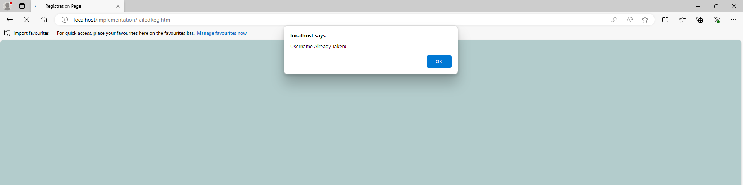

**Page after “ok” has been pressed**

**failedReg.html code**

<!DOCTYPE html>

<html>

<head>

<title>Registration Page</title>

<link rel="stylesheet" type="text/css" href="css/style.css"> <!-- CSS link -->

<script> //ensure that value of first password matches second or error message is displayed until it is

function check() {

var input = document.getElementById('password_confirm');

if (input.value != document.getElementById('password').value) {

input.setCustomValidity('Passwords Must be Matching.');

} else {

// input is valid -- reset the error message

input.setCustomValidity('');

}

}

function myFunction() {

alert("Username Already Taken!");

}

</script>

</head>

<body onload="myFunction()">

<!-- Page Header -->

<h1 id="regHead">leBaie</h1>

<h3 id="regH2">Create Account</h3>

<div id="regDiv" align="center">

<section id="sectionReg">

<form id="regForm" method="POST" action="process.php">

<p>Username: <input id="errorUser" type ="text" size="25" maxlength="10" name="username" value="" required > </p> <br>

<p>First Name: <input type ="text" maxlength="20"size="24" name="firstname" value="" required> </p> <br>

<p>Surname: <input type ="text" maxlength="20" size="26" name="surname" value="" required> </p> <br>

**failedReg.html code (2)**

<p>Date of Birth: <input id="DOBreg" type ="date" size="5" name="DOB" value="dd/mm/yyyy" min="1940-12-31" max="2012-12-31" required> </p> <br>

<p> <label for="password">Password:</label> <input name="password" required="required" type="password" id="password" size="26" maxlength="20" oninput="check()"/>

</p> <br>

//uses javascript function to check if both passwords match

<p><label for="password_confirm">Confirm Password:</label> <input name="password_confirm" required="required" size="16" type="password" id="password_confirm" maxlength="20" oninput="check()"/>

</p><br>

<button type="submit">Create Account</button>

</form>

<a id="homeRegLink" href="home.php">continue as guest</a>

<a href="loginPage.html">login</a>

</section>

</div>

</body>

</html>

**invalidLogin.html**

**invalidLogin.html code**

<!DOCTYPE html>

<html>

<head>

<title>Login Page</title>

<link rel="stylesheet" type="text/css" href="css/style.css"> <!-- CSS link -->

<!-- uses javascript function to display error message -->

<script>function myFunction() {

alert("Invalid Username or Password!");

}</script>

</head>

//runs javascript function on pageload

<body onload="myFunction()">

<!-- Page Header -->

<h1 id="loginHead">leBaie</h1>

<h3 id="loginH2">Login Page</h3>

<div id="loginDiv" align="center">

<section id="sectionLogin">

<form id="loginForm" method="POST" action="login.php">

<p>Username: <input type ="text" size="30" maxlength="10" name="username" value="" required > </p> <br>

<p class="passLog">Password: <input name="password" required="required" type="password" size="30" maxlength="20"> </p>

<button type="submit">Login</button>

</form>

<a id="homeRegLink" href="home.php">continue as guest</a>

<a href="registrationPage.html">register here</a>

</section>

</div>

</body>

</html>

**vehiclesPage.php**

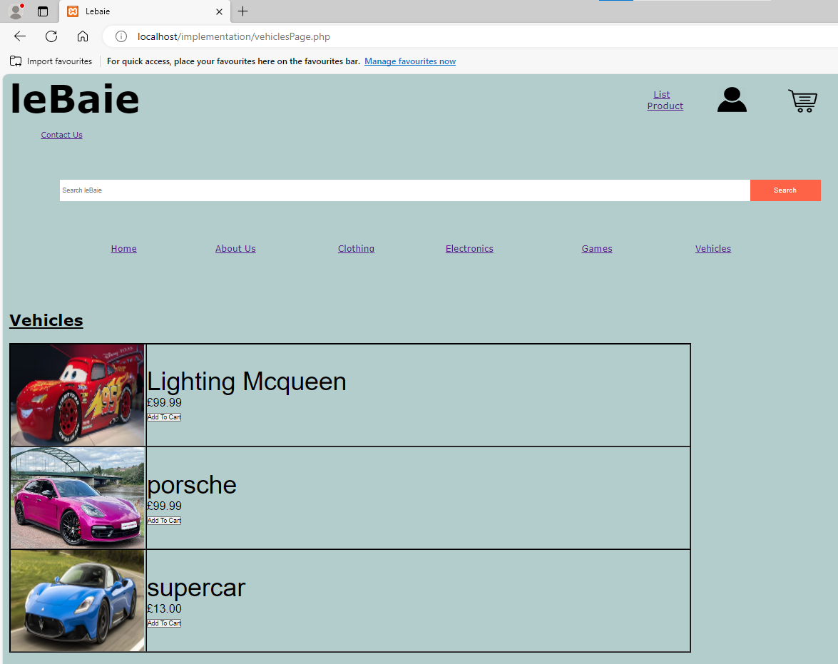

**vehiclesPage.php code**

<?php

// Start the session

session_start();

?>

<!DOCTYPE html>

<html>

<head>

<title>Lebaie</title>

<link rel="stylesheet" type="text/css" href="css/style.css"> <!-- CSS link -->

</head>

<body>

<header>

<h1 class="loggedHeader">leBaie</h1>

<li><a id="listProduct" href="listingPage.html">List Product</a></li>

<li><a id="profileImage" href="profile.php"><img id="profileImage" src="media/profile-icon-png-908.png"></a></li>

<li><a id="basketImage" href="basket.php"> <img id="basketImage" src="Media/cart.png"> </a></li><br><br><br><br><br><br>

<li><a id="contactUsID" href="contactUs.html">Contact Us</a></li> <br><br><br>

</header>

<!-- search bar and search button for signed in pages -->

<div class="container">

<form id="searchButton" method="GET" action="results.php">

<input type="text" placeholder="Search leBaie" name="search">

<button type="submit">Search</button>

</form>

</div>

<!-- Navigation Bar -->

<nav>

<ul>

<li><a id="homePageID" href="RegisteredHome.php">Home</a></li>

<li><a href="aboutUs.html">About Us</a></li>

<li><a href="clothingPage.php">Clothing</a></li>

<li><a href="electronicsPage.php">Electronics</a></li>

**vehiclesPage.php code (2)**

<li><a href="gamesPage.php">Games</a></li>

<li><a href="vehiclesPage.php">Vehicles</a></li>

</ul>

</nav>

<main>

<section>

<h2 id="resultsH2">Vehicles</h2>

<br><br><br>

<div class="resultsDiv">

<?php

//sets up db

$servername="localhost";

$username="root";

$password="";

$dbname="leBaieBase";

// Create connection

$conn = mysqli_connect($servername, $username, $password, $dbname);

// Check connection

if (!$conn) {

die("Connection failed: " . mysqli_connect_error());

}

//gets values from SQL db table (products) then assigns them to sql

$sql = "SELECT `productName`,`productCategory`, `price`, `image` FROM `products` WHERE `productCategory`='vehicle'";

$result = mysqli_query($conn, $sql);

//querys the db to get all the data for products in the vehicle category

if (mysqli_num_rows($result) > 0) {

echo "<table border='1'>";

// output data of each row - uses php variables in order to match users search and concatenate html variables

while($row = mysqli_fetch_assoc($result)) {

**vehiclesPage.php code (3)**

$image= $row["image"];

echo "<tr>

<td>". '<img src="media/'.$image.'" class="resultsImage">'. "</td>

<td class='resultsName'>". $row['productName']. '<br> <div class="resP">£' .$row['price']."<br>

<form id='searchButtonRes' method='GET' action='basketProcess.php'>

<button type = 'submit' name = 'cartBtn' Value = ".$row["productName"]. " 'class= 'resultsPageAdd'>Add To Cart</button> </td></div>

</form>

</tr>";}

echo "</table>";}

else {

echo "There were no results matching your search, sorry!";

}

//close connection

mysqli_close($conn);

?>

</div>

</section>

</main>

</body>

</html>

**resultsUnlogged.php**

**search input was “modern warfare 3”**

**resultsUnlogged.php (2)**

**message displayed when no search results are found**

**resultsUnlogged.php code**

<?php

// Start the session

session_start();

?>

<!DOCTYPE html>

<html>

<head>

<title>Lebaie</title>

<link rel="stylesheet" type="text/css" href="css/style.css"> <!-- CSS link -->

</head>

<body>

<header>

<h1 class="loggedHeader">leBaie</h1>

<li><a id="listProduct" href="listingPage.html">List Product</a></li>

<li><a id="profileImage" href="profile.php"><img id="profileImage" src="media/profile-icon-png-908.png"></a></li>

<li><a id="basketImage" href="basket.php"> <img id="basketImage" src="Media/cart.png"> </a></li><br><br><br><br><br><br>

<li><a id="contactUsID" href="contactUs.html">Contact Us</a></li> <br><br><br>

</header>

<!-- search bar and search button for signed in pages -->

<div class="container">

<form id="searchButton" method="GET" action="results.php">

<input type="text" placeholder="Search leBaie" name="search">

<button type="submit">Search</button>

</form>

</div>

<!-- Navigation Bar -->

<nav>

<ul>

<li><a id="homePageID" href="RegisteredHome.php">Home</a></li>

<li><a href="aboutUs.html">About Us</a></li>

<li><a href="clothingPage.php">Clothing</a></li>

<li><a href="electronicsPage.php">Electronics</a></li>

**resultsUnlogged.php code (2)**

<li><a href="gamesPage.php">Games</a></li>

<li><a href="vehiclesPage.php">Vehicles</a></li>

</ul>

</nav>

<main>

<section>

<h2 id="resultsH2">Results</h2>

<br><br><br>

<div class="resultsDiv">

<?php

$servername="localhost";

$username="root";

$password="";

$dbname="leBaieBase";

$userSearch=$_GET["search"];

// Create connection

$conn = mysqli_connect($servername, $username, $password, $dbname);

// Check connection

if (!$conn) {

die("Connection failed: " . mysqli_connect_error());

}

// select items in database where user search matches/similar product in database

$sql = "SELECT `productName`,`productCategory`, `price`, `image` FROM `products` WHERE `productName` like '%$userSearch%'";

$result = mysqli_query($conn, $sql);

if (mysqli_num_rows($result) > 0) {

echo "<table border='1'>";

//look at if product cat cant be input type = text

// output data of each row - uses php variables in order to match users search and concatenate html variables

**resultsUnlogged.php code (3)**

while($row = mysqli_fetch_assoc($result)) {

$image= $row["image"];

echo "<tr>

<td>". '<img src="media/'.$image.'" class="resultsImage">'. "</td>

<td class='resultsName'>". $row['productName']. '<br> <div class="resP">£' .$row['price']."<br>

<form id='searchButtonRes' method='GET' action='basketProcess.php'>

<button type = 'submit' name = 'cartBtn' Value = ".$row["productName"]. " 'class= 'resultsPageAdd'>Add To Cart</button> </td></div>

</form>

</tr>";}

echo "</table>";}

else {

echo "There were no results matching your search, sorry!";

}

mysqli_close($conn);

?>

</div>

</section>

</main>

</body>

</html>

**Results.php**

**message displayed when no search results are found**

**results.php (2)**

**input was “Medal”**

**results.php code**

<?php

// Start the session

session_start();

?>

<!DOCTYPE html>

<html>

<head>

<title>Lebaie</title>

<link rel="stylesheet" type="text/css" href="css/style.css"> <!-- CSS link -->

</head>

<body>

<header>

<h1 class="loggedHeader">leBaie</h1>

<li><a id="listProduct" href="listingPage.html">List Product</a></li>

<li><a id="profileImage" href="profile.php"><img id="profileImage" src="media/profile-icon-png-908.png"></a></li>

<li><a id="basketImage" href="basket.php"> <img id="basketImage" src="Media/cart.png"> </a></li><br><br><br><br><br><br>

<li><a id="contactUsID" href="contactUs.html">Contact Us</a></li> <br><br><br>

</header>

<!-- search bar and search button for signed in pages -->

<div class="container">

<form id="searchButton" method="GET" action="results.php">

<input type="text" placeholder="Search leBaie" name="search">

<button type="submit">Search</button>

</form>

</div>

<!-- Navigation Bar -->

<nav>

<ul>

<li><a id="homePageID" href="RegisteredHome.php">Home</a></li>

<li><a href="aboutUs.html">About Us</a></li>

<li><a href="clothingPage.php">Clothing</a></li>

<li><a href="electronicsPage.php">Electronics</a></li>

**results.php code (2)**

<li><a href="gamesPage.php">Games</a></li>

<li><a href="vehiclesPage.php">Vehicles</a></li>

</ul>

</nav>

<main>

<section>

<h2 id="resultsH2">Results</h2>

<br><br><br>

<div class="resultsDiv">

<?php

$servername="localhost";

$username="root";

$password="";

$dbname="leBaieBase";

//receive html form elements using get method as no need for search to be secure

$userSearch=$_GET["search"];

// Create connection

$conn = mysqli_connect($servername, $username, $password, $dbname);

// Check connection

if (!$conn) {

die("Connection failed: " . mysqli_connect_error());

}

//select items in the database that match users search and then query the database for results

$sql = "SELECT `productName`,`productCategory`, `price`, `image` FROM `products` WHERE `productName` like '%$userSearch%'";

$result = mysqli_query($conn, $sql);

if (mysqli_num_rows($result) > 0) {

echo "<table border='1'>";

**results.php code (3)**

// output data of each row - uses php variables in order to match users search and concatenate html variables

while($row = mysqli_fetch_assoc($result)) {

$image= $row["image"];

echo "<tr>

<td>". '<img src="media/'.$image.'" class="resultsImage">'. "</td>

<td class='resultsName'>". $row['productName']. '<br> <div class="resP">£' .$row['price']."<br>

<form id='searchButtonRes' method='GET' action='basketProcess.php'>

<button type = 'submit' name = 'cartBtn' Value = ".$row["productName"]. " 'class= 'resultsPageAdd'>Add To Cart</button> </td></div>

</form>

</tr>";}

echo "</table>";}

else {

echo "There were no results matching your search, sorry!";

}

mysqli_close($conn);

?>

</div>

</section>

</main>

</body>

</html>

**Style.css**

/* Remove browser defaults */

* {margin:0;padding:0}

body {margin:auto}

/* Styling for header section*/

h1{display:inline;

float:left;

margin-right:775pt;

margin-left:10pt;

font-size:60pt}

#contactUsID{display:block; margin-left:60pt;}

header {list-style-type:none}

#regPageID, #loginPageID{float:left;text-align:center; font-size:16pt; margin-top:20pt}

#regPageID,#loginPageID{margin-right:60pt}

/* Styling for entire page*/

header, body{background:#b3cccc;font-family:Verdana, sans-serif}

body{width:1300}

/* Nav Styling - Add more*/

nav{margin-left:30pt}

nav {margin-top:15px; margin-bottom:120px;}

nav {height:30px}

nav {font-family: Verdana, sans-serif; font-size: 14pt;}

nav ul {list-style-type:none}

nav ul li {float:left;width:250px;text-align:right}

nav ul li a {display:block;padding:8px}

/* Positioning (Float, Display and Clear) */

nav, main, header {clear:both}

/* Search Bar Styling*/

.container{ margin-left:90pt;

margin-bottom:60pt;

margin-top:20pt;

}

#searchButton{display:flex;

**Style.css (2)**

width:1600px;

height:45px;}

#searchButton input{flex:1;

border:none;

outline:none;

padding:5px;}

#searchButton button{

background:tomato;

padding:10px 50px;

border:none;

outline:none;

color: #fff;

cursor:pointer;

letter-spacing:1px;}

/* Styling for products of the month columns*/

h2{float:left; display:inline; margin-left:10pt}

/* Styling for registration page (also used in login page)*/

#regHead{margin-left:620pt;

margin-top:10px;

padding-bottom:10pt;}

#regH2{margin-left:650pt;

padding-bottom:50pt;

}

#regForm{

width:40pt;

display:inline;

size:10pt;

width:400pt;

margin-top:20pt

}

**Style.css (3)**

#regForm button {height:30px;width:300px; display:block; margin-bottom:10pt }

#homeRegLink {margin-bottom:10pt; display:block}

#DOBreg{width:125pt; height:15pt; }

#sectionReg{

border: 2px solid black;

border-radius: 5px;

width:450px;

height:450px;

padding-top:100px;

}

/* Media Query for different devices (for screens less than 1500, zoom website will zoom further out)*/

@media (max-width:1500px){

body{

zoom:78%;}

header{zoom:98%;}

}

/* Styling for about us page (logged and unlogged)*/

.aboutUsNav{margin-bottom: 55pt;}

.aboutSection{ border: 1px solid black;

border-radius: 5px;

width:1750px;

height:300px;

padding-top:50px;

margin-left: 20pt;

padding-left:20px;

font-size:15pt;

}

.aboutTxt{margin-right: 10pt;}

.aboutUs{margin-left:20pt;

margin-bottom:30pt;

font-size: 18pt;}

.me{width:150pt; height: 195pt; float:right; display:inline; margin-left: 30pt; margin-right: 8pt;

**Style.css (4)**

}

#LogOut{margin-right: 280pt;

margin-top: 20pt;

float:right;

font-family: Verdana, sans-serif; font-size: 17pt;}

/* Styling for header of every logged in page*/

#profileImage, #basketImage, #listProduct, #basketImageUnlogged {width:46pt; height:40pt; float:left; margin-right: 65pt;}

.loggedHeader{display:inline;

float:left;

margin-right:800pt;

margin-left:10pt;

font-size:60pt}

#listProduct{font-size: 15pt; text-align:center; margin-top: 23pt;}

#basketImage {margin-top: 11pt;}

#profileImage{margin-top: 10pt;}

/* Styling for login page*/

#loginForm{

width:40pt;

display:inline;

size:25pt;

font-size:20pt;

margin-top:20pt

}

#loginHead{margin-left:620pt;

margin-top:10px;

padding-bottom:10pt;}

#loginH2{margin-left:640pt;

padding-bottom:50pt;

font-size:25pt;}

#sectionLogin{

**Style.css (5)**

border: 2px solid black;

border-radius: 5px;

width:600px;

height:300px;

padding-top:100px;

}

#loginForm button {height:30px;width:300px; display:block; margin-bottom:10pt }

.passLog{margin-bottom: 20pt;}

/* Styling for listing page*/

#productCon{margin-bottom:15px;}

#listingNav{margin-bottom:70pt;}

#listingForm{

display: block;}

#fileListing{margin-top: 10pt; size:15pt}

#loginForm{

display:inline;

size:25pt;

font-size:20pt;

margin-top:20pt

}

#listingSubmit{

width:335pt;

size:50pt }

#productCat{margin-bottom: 10pt;}

/* Styling for Contact Us page*/

#contactHeader{margin-bottom: 15pt;

margin-left: 15pt ;}

#contactForm{margin-left:15pt}

#contactSubmit{

**Style.css (6)**

width:335pt;

size:50pt;

margin-top: 10pt;}

#profileH1{margin-bottom:60pt; }

/* Styling for Contact Us page*/

.profileInfo{ font-size: 20px;

font-family:Verdana, sans-serif;

margin-left: 10pt;

margin-bottom: 10pt;

width:400pt}

#profileHeading{display:block;

margin-right:10pt;

margin-bottom:40pt;

margin-top:20pt;

font-size: 25px;

margin-left:10pt}

#editButton {

margin-left:10pt;

width:130pt;

size:20pt;}

#saveProfile{

margin-left:10pt;

width:180pt;

size:20pt;}

/* Styling for results page*/

#resultsDiv{font-size: 25pt;}

table {

margin-top: 10px;

margin-left:10pt;

border-collapse: separate;

**Style.css (7)**

border-spacing: 1px;

width:50%;

border: 1px solid black;

}

tr {

font-family: Arial, Helvetica, sans-serif;

font-size: 15pt;

}

td {

font-family: Arial, Helvetica, sans-serif;

font-size: 12pt;

margin-top: 10pt;

width: 20%; height: 160pt;

padding-right: 2pt;

}

.resultsName{font-size: 40pt; width: 90%;}

.resultsImage{ width:100%; height:100%; display: block;}

.resP{font-size: 18pt;}

#resultsH2{font-size:25pt;

margin-bottom: 15pt;

display: block;

text-decoration: underline;}

/* Styling for basket page*/

.basketButton{size:40pt;

height:30px; width:975px; margin:5pt; }

**TESTING**

**Log of ongoing testing**

|  |  |  |
| --- | --- | --- |
| **Date** | **Issue** | **Solution** |
| **17/12/23** | **User Data not being inserted into database for registering** | **server-side syntax was not correct** |
| **19/12/23** | **user profile details not updating** | **had to update serverside form variables as they did not correspond to form variable name** |
| **29/12/23** |  |  |
| **05/01/24** |  |  |
| **09/01/24** |  |  |
| **14/01/24** |  |  |

**Test Plan**

|  |  |
| --- | --- |
| **Functional and end-user requirements** | **Complete** |
|  |  |
|  |  |
|  |  |
|  |  |
|  |  |

**Form validation**

**Registration page (registration.html) validation**

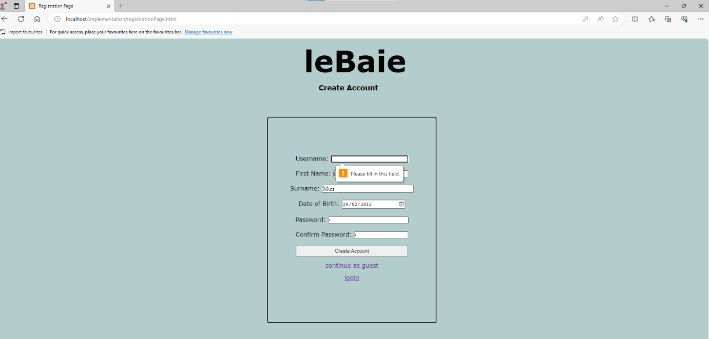

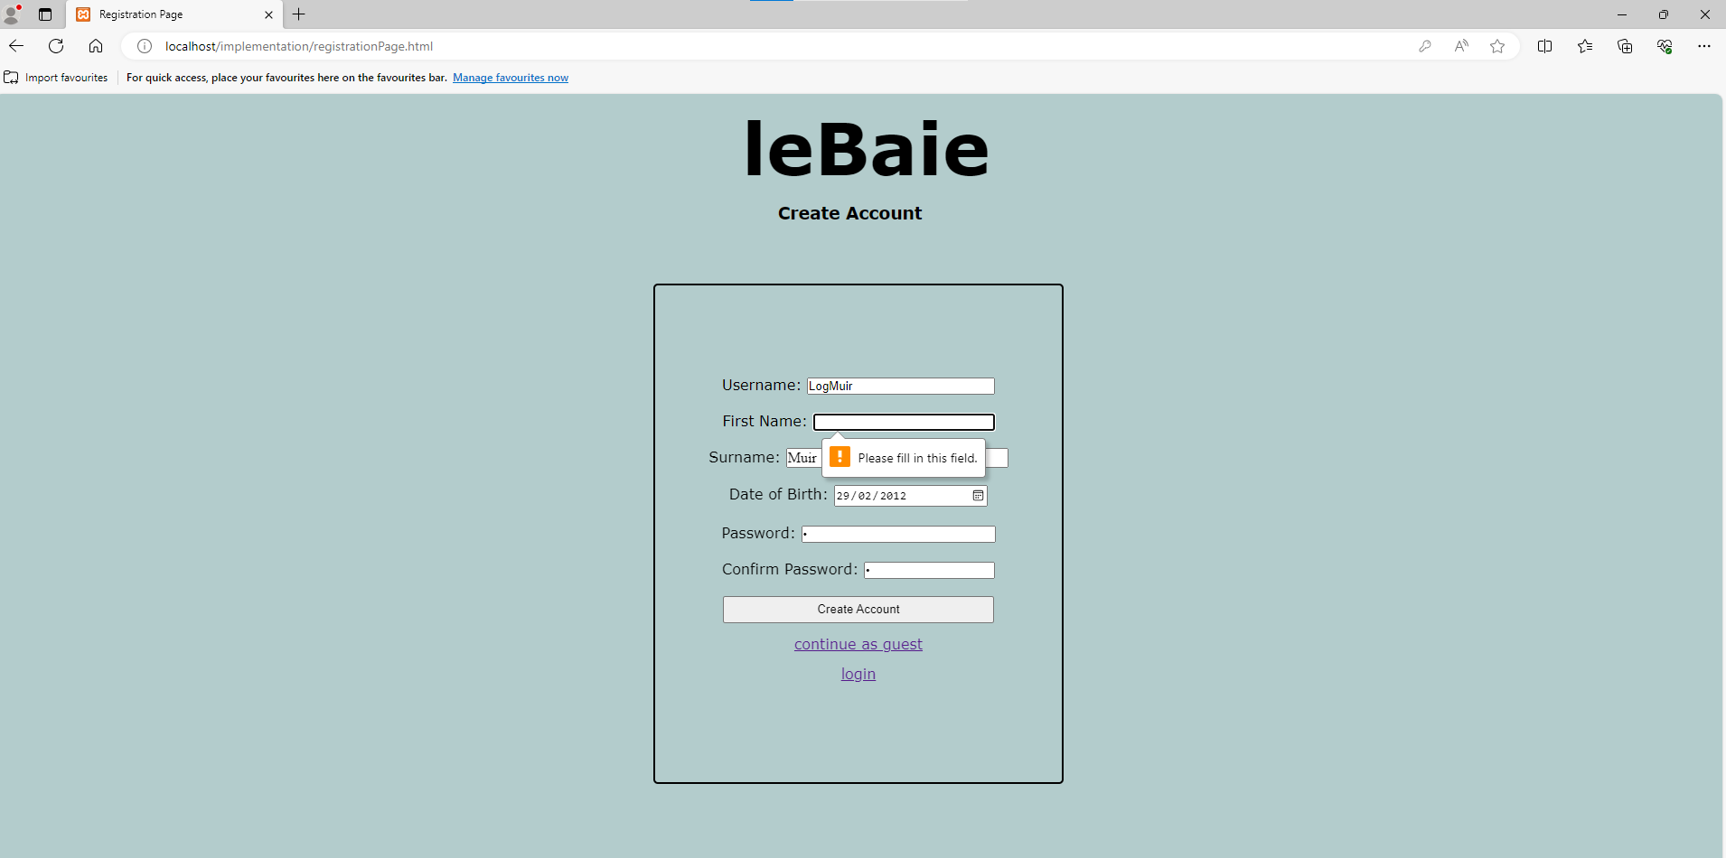

**Registration page (registration.html) validation (2)**

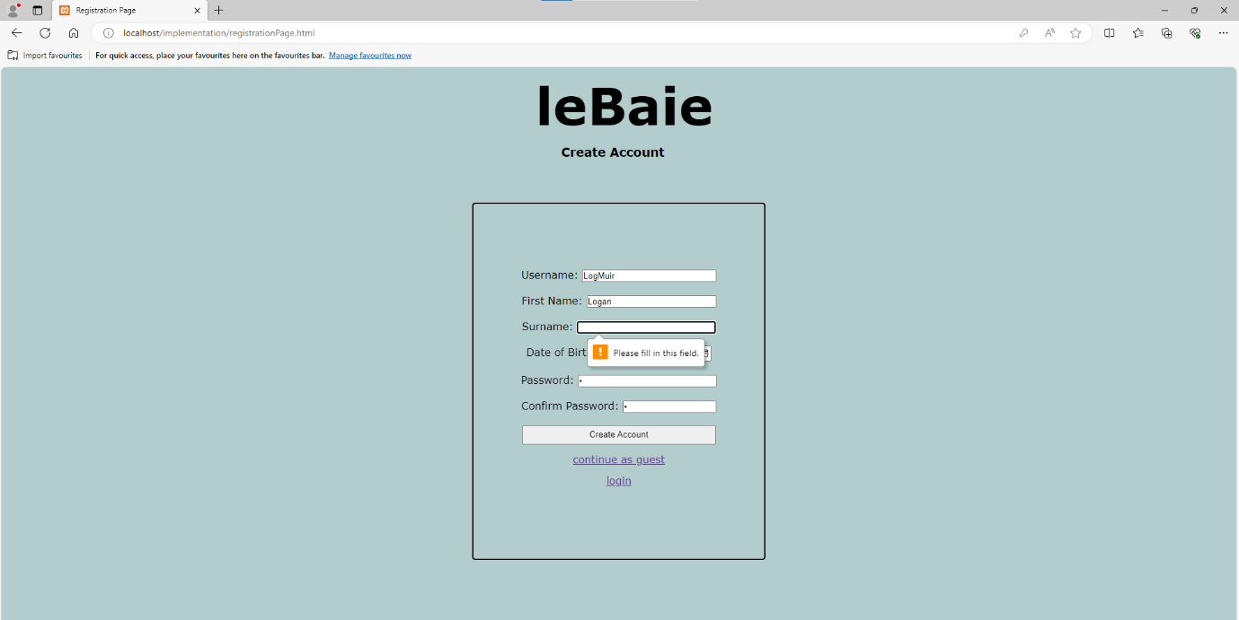

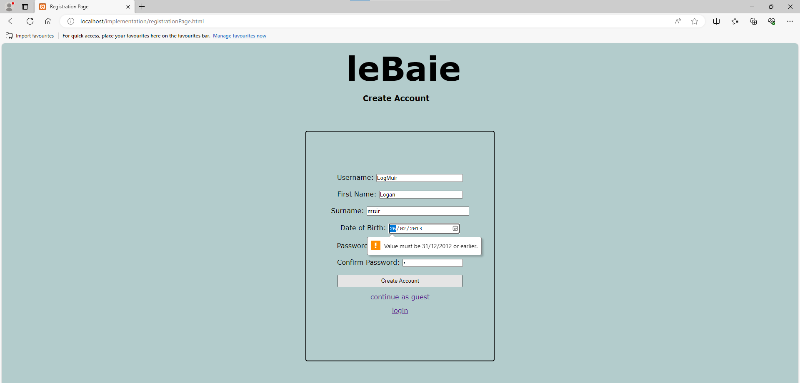

**Registration page (registration.html) validation (3)**

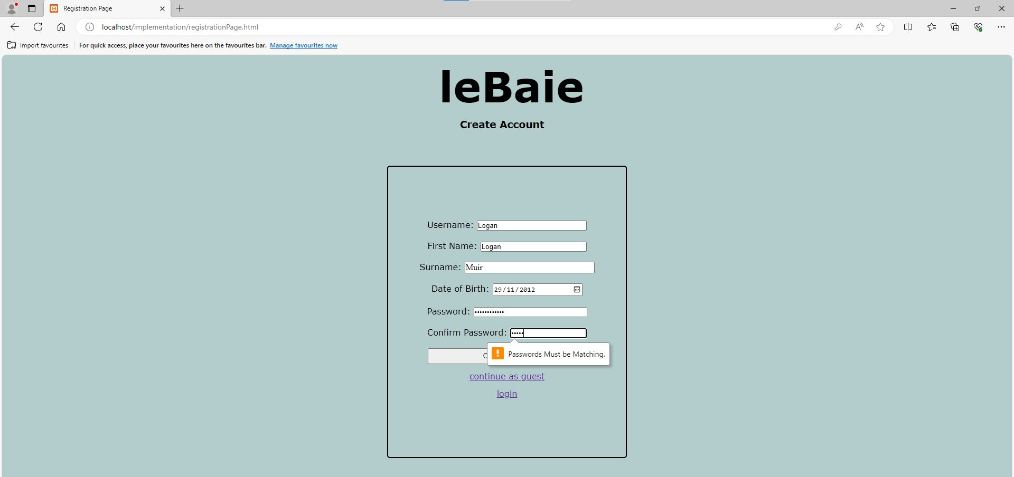

**Message displayed when username already exists (user is redirected)**

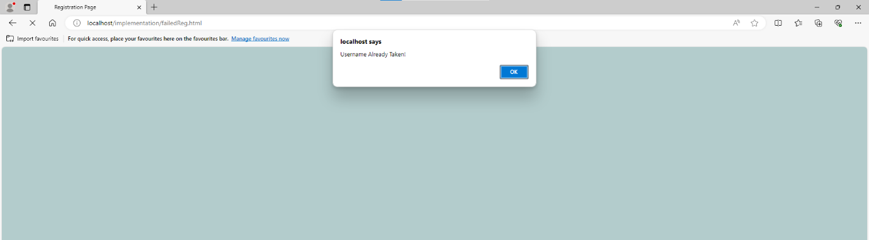

**FailedReg.html has exact same validation and form elements as registrationPage.html**

**login page validation (login.html)**

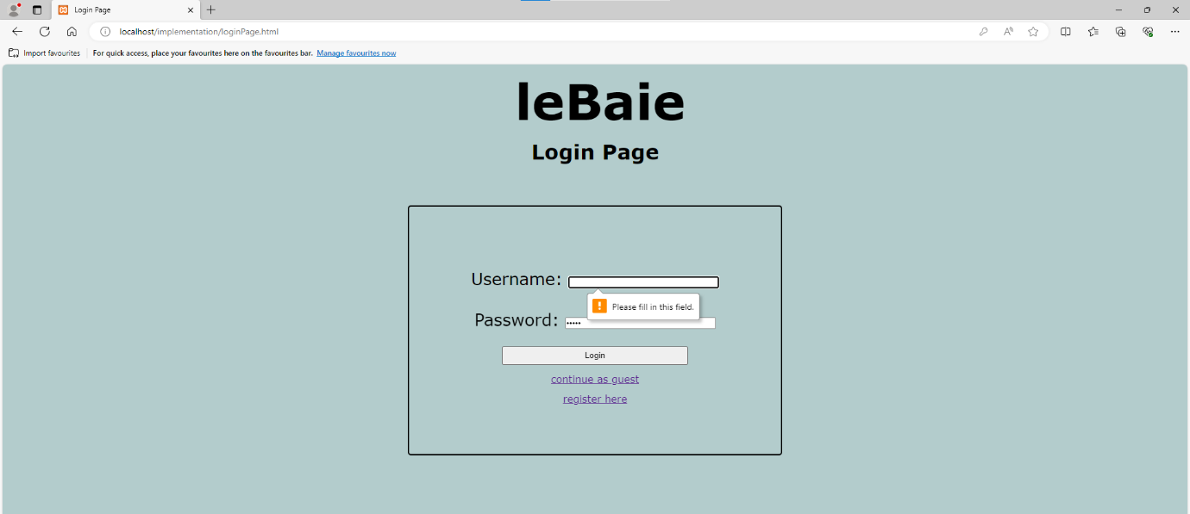

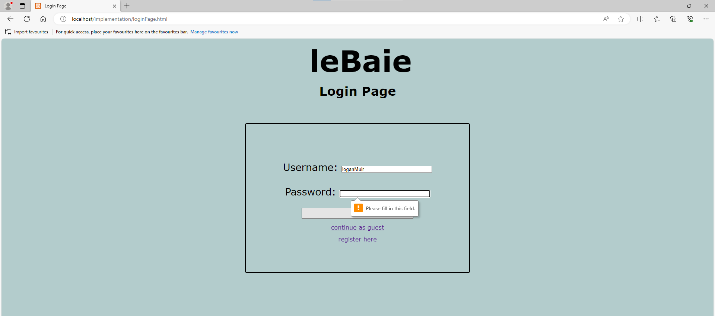

**invalidLogin.html validation and popup message (it’s the page user is redirected to when incorrect login details are entered**

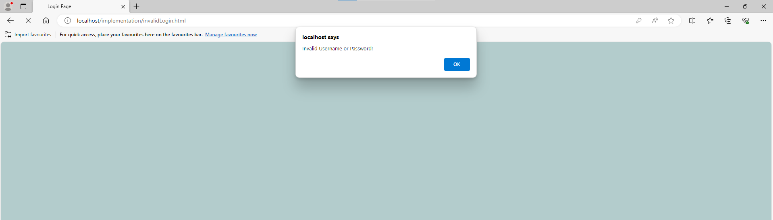

**invalidLogin.html contains exact same validation and form elements as login.html**

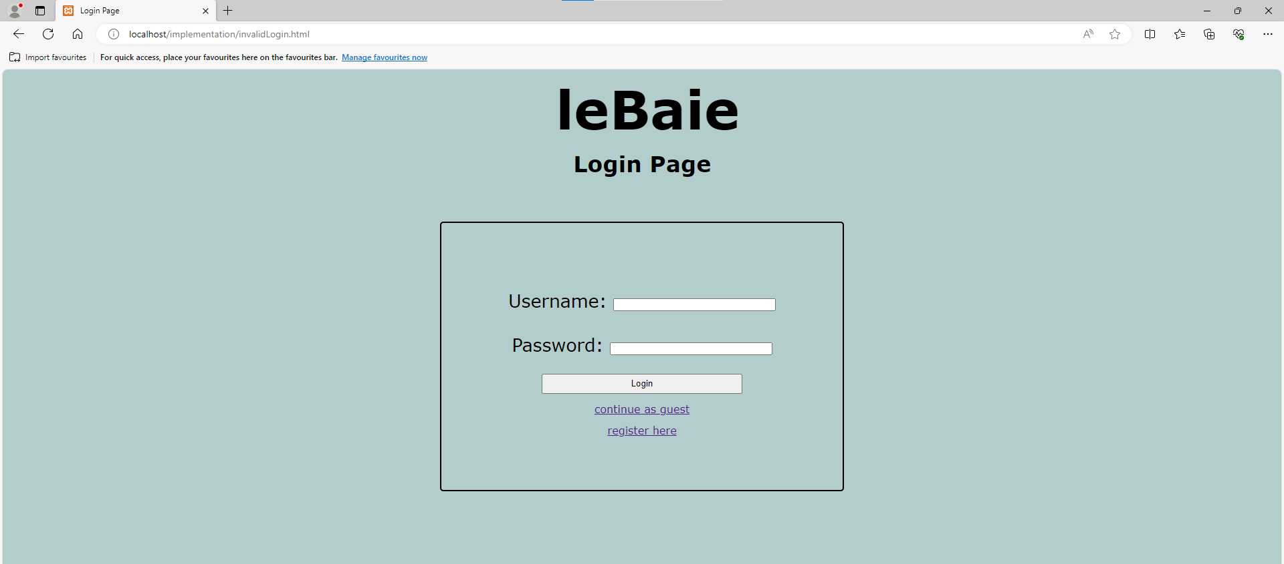

contactUsGuest.html form validation (username isn’t required)

